**Github Repository Link:-**

**To automate functionalities using https://petstore.swagger.io/ REST API services**

**Postman**

Click on workspace at top header section and create workspace

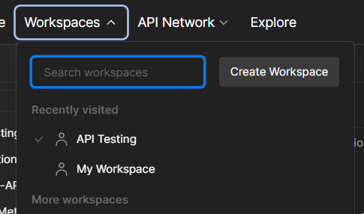

Select the Blank workspace and click on next

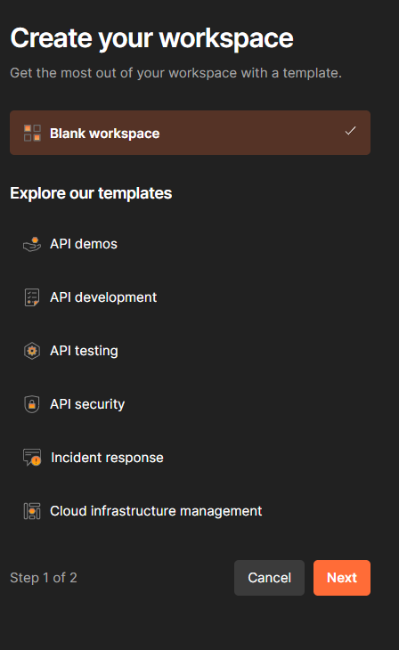

Give the name for workspace and choose the workspace type and click on create. It will create a new workspace.

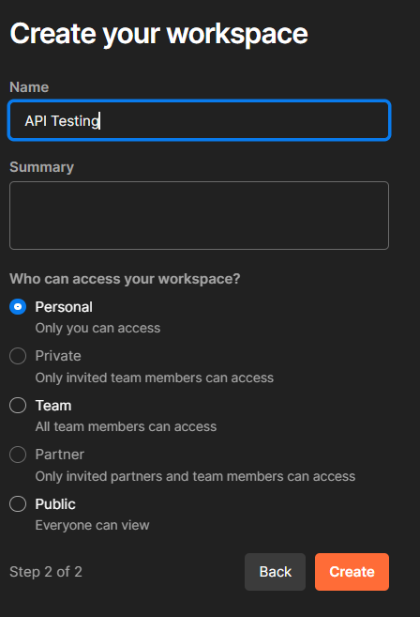

To create a new collection click on collection at left side headers and then click on ‘+’ symbol and select blank collection then give the name to the collection.

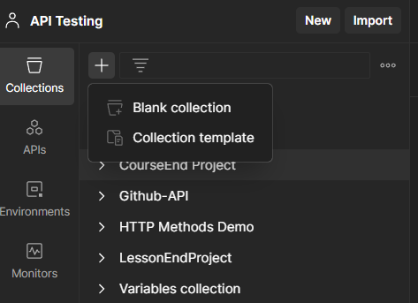

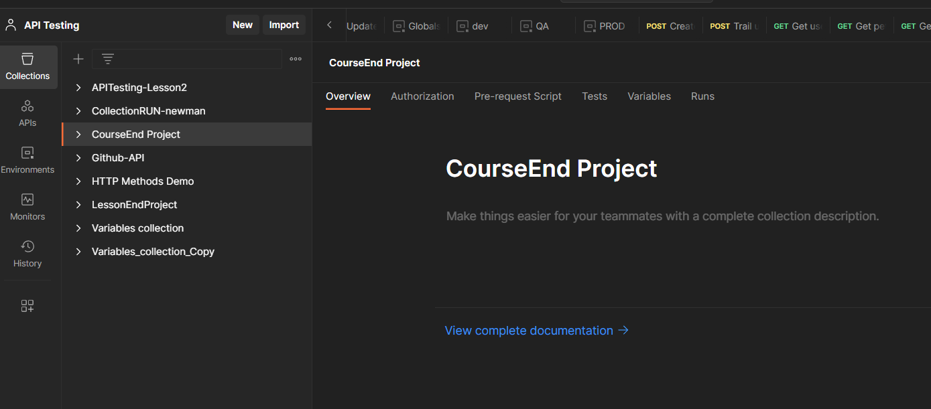

**Postman Assignment 001**

**Request - 1**

To create a Request in the collection.

Right click on target collection->select Add Request. And then we can change the request name if we want.

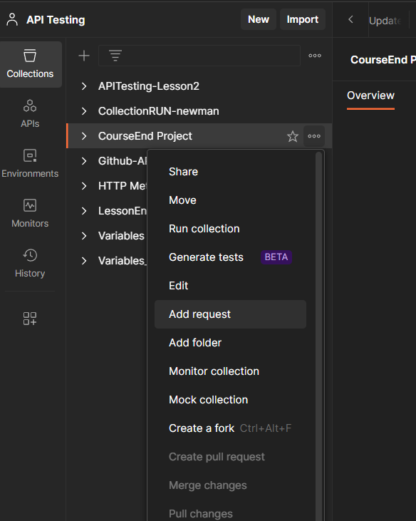

After creating a request. Given the https link in tab and selected the POST method.

Added the body section for creating the pet details.

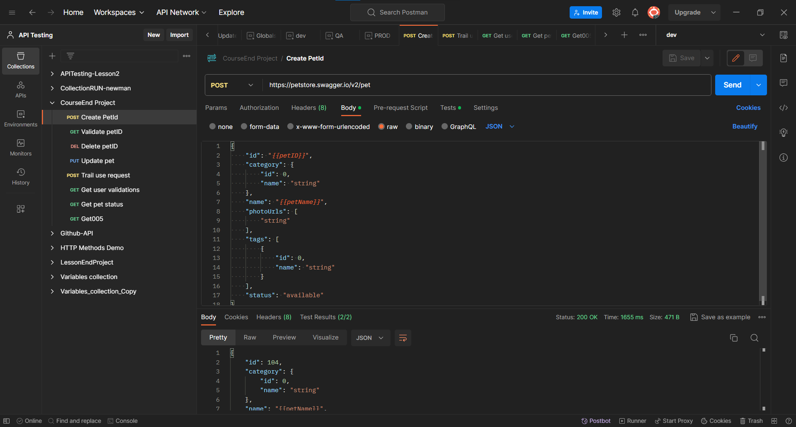

And then added the Test cases in the Tests header section.

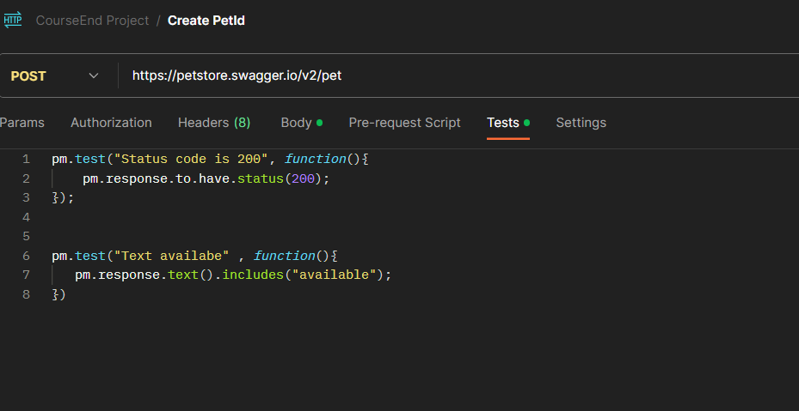

Created a Excel sheet with .csv extension by adding the PetID and PetNames.

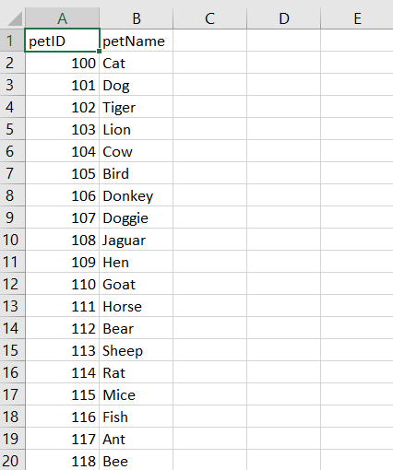

To run the collection with runner collection by providing the data in parameterised way.

Right click on target collect-> select Runner collection

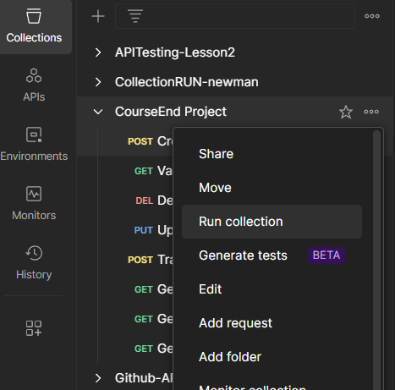

Selected the Requests and added the csv file and click on Run.

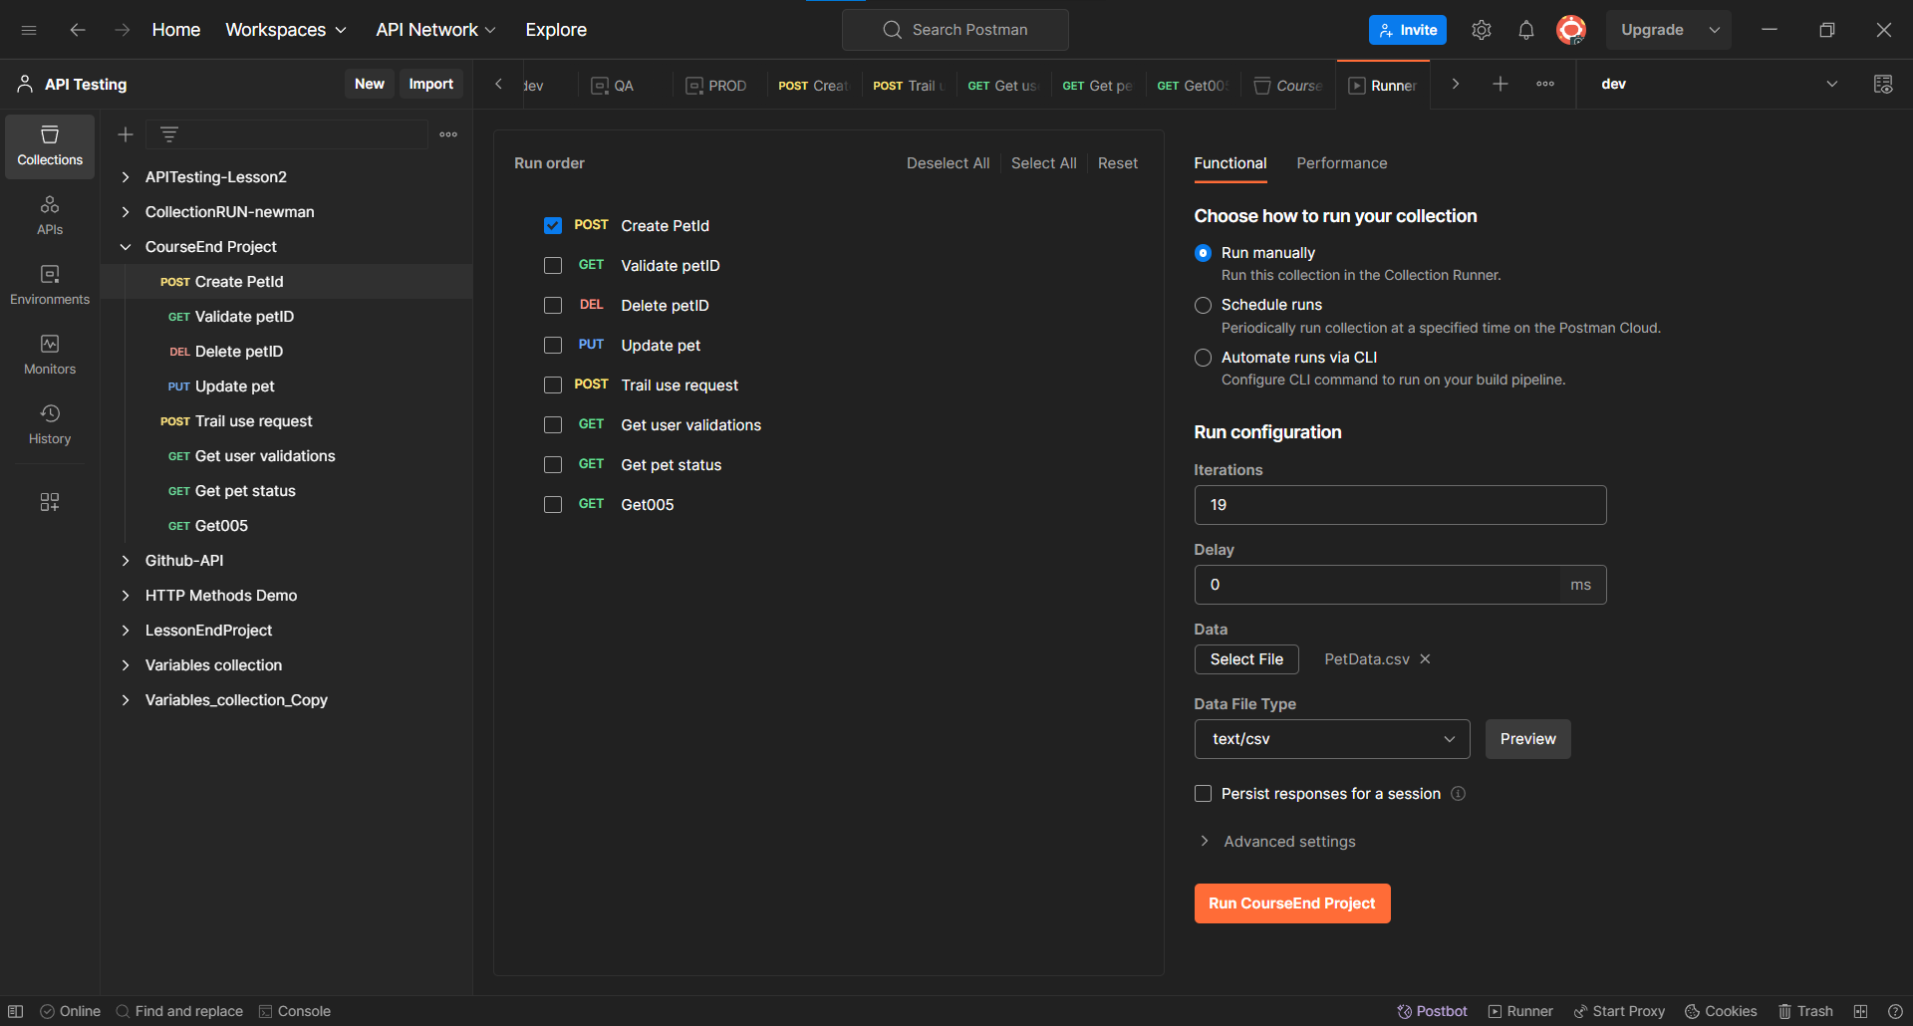

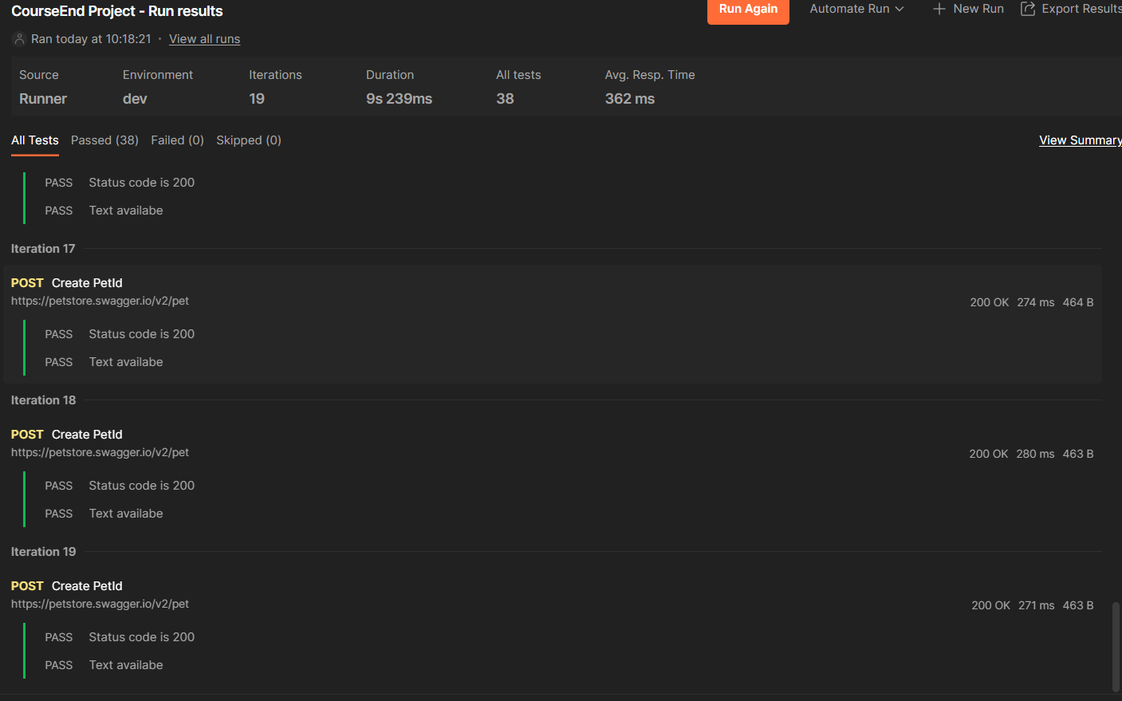

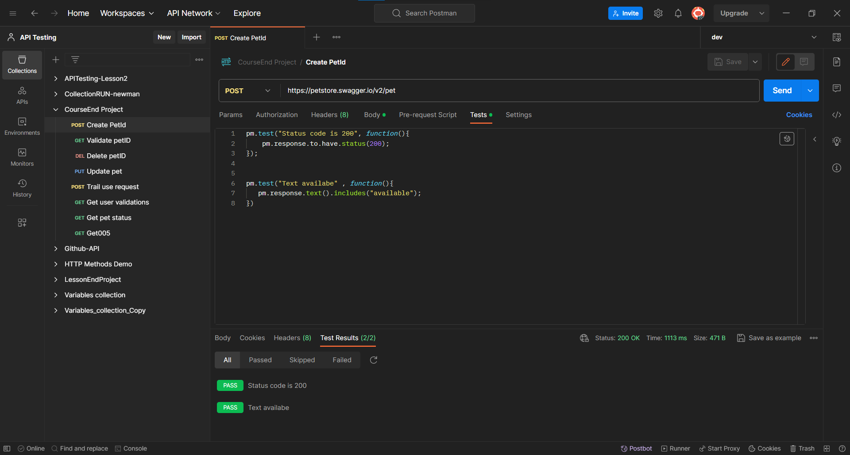

**Request-2**

Added the new Request in the same collection. Given the https link in tab and selected the GET method. To get the pet details.

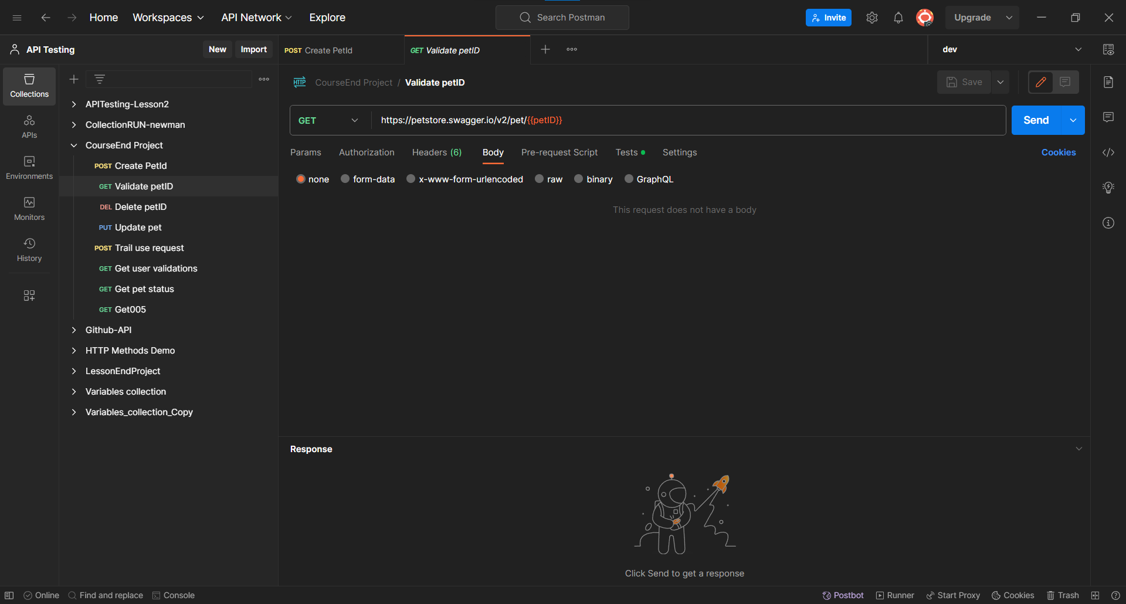

Added the Test cases on the tests header section.

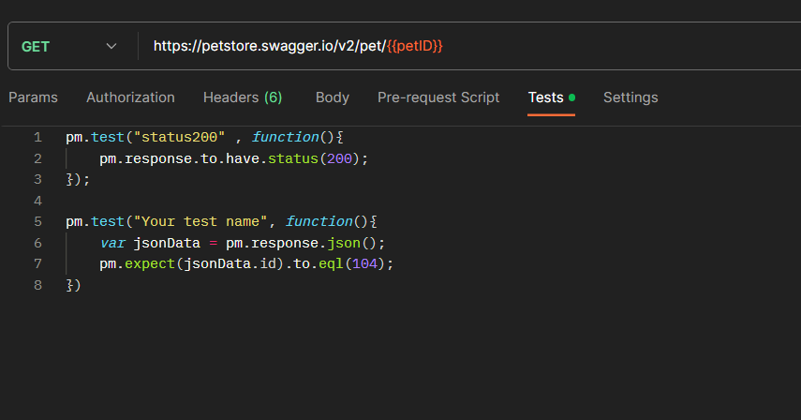

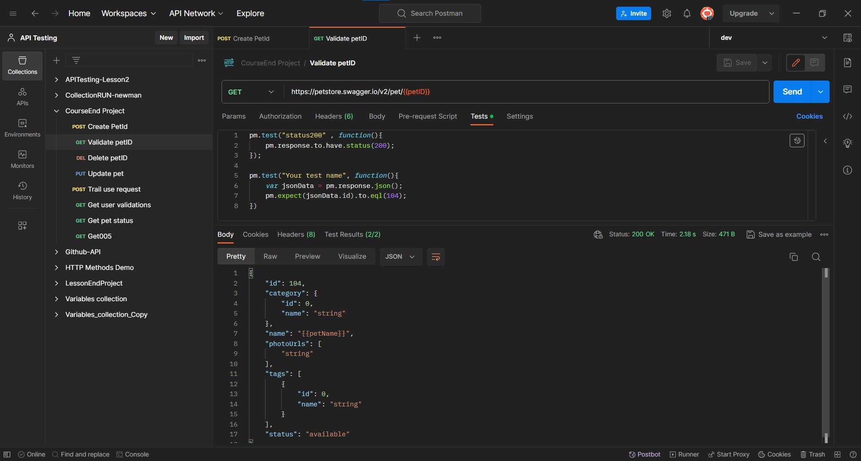

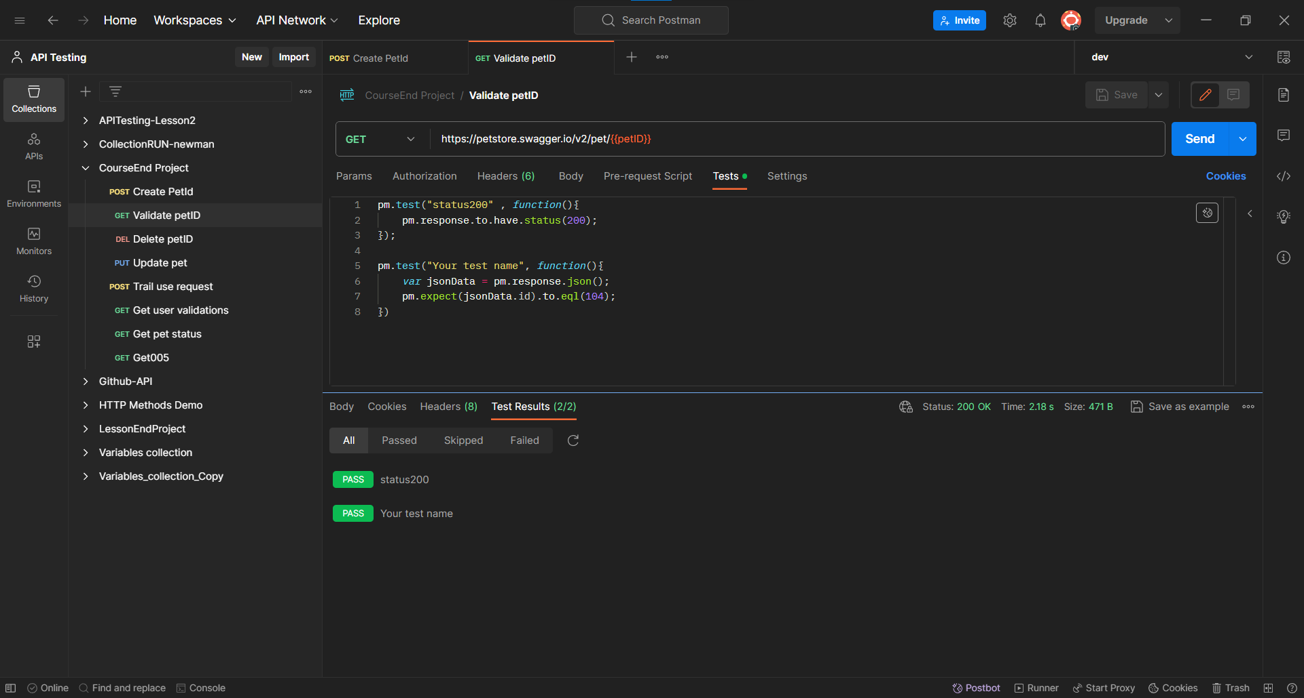

**Request-3**

Added the new Request in the same collection. Given the https link in tab and selected the DELETE method. To delete the pet details by petID.

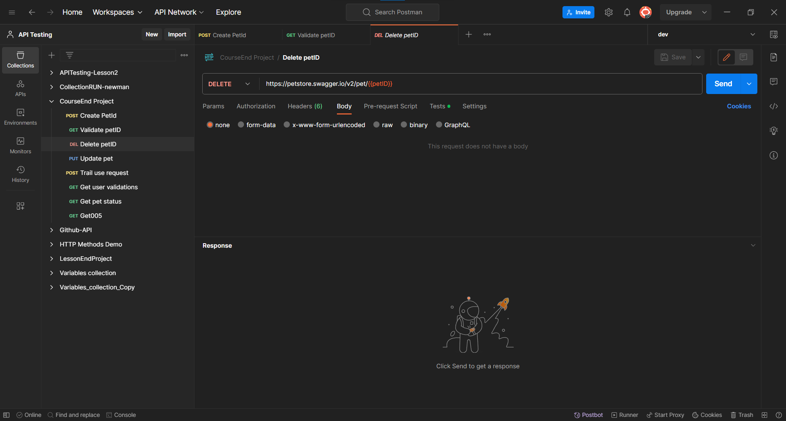

Added the Test cases in the tests header section.

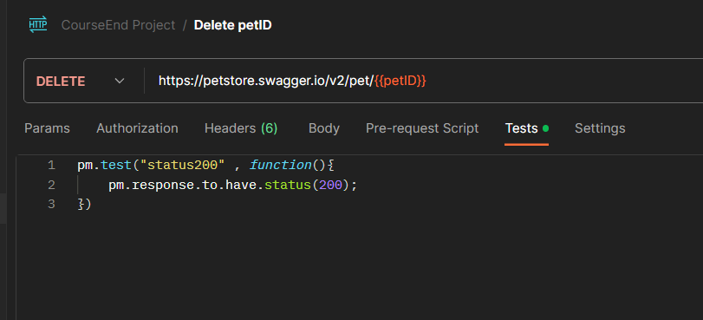

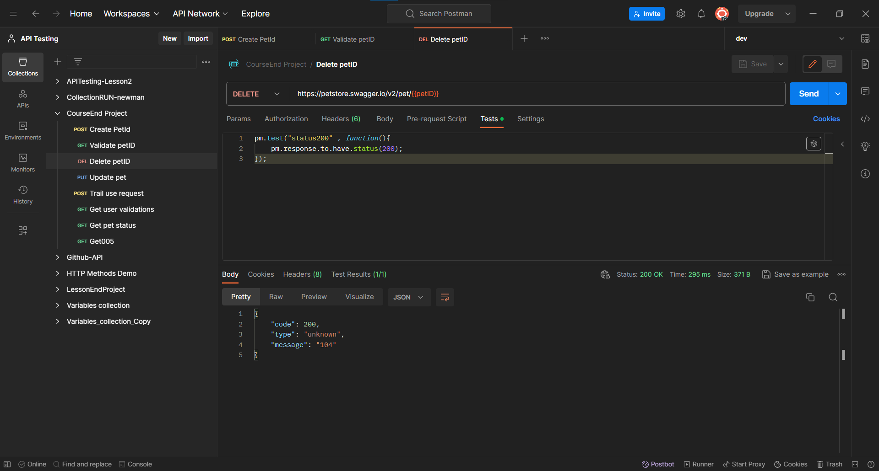

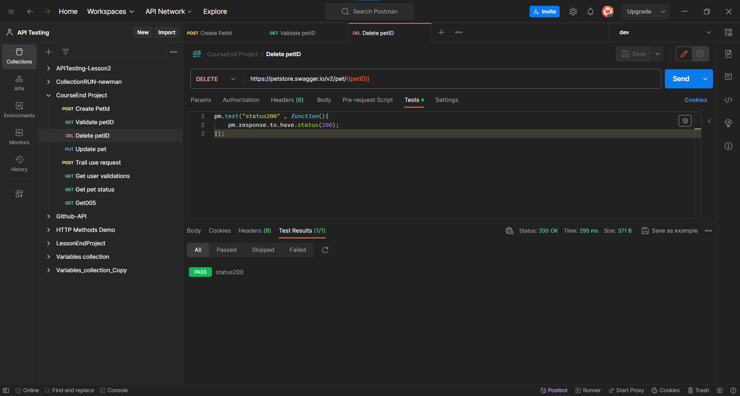

**Postman Assignment 002**

Added the new Request in the same collection. Given the https link in tab and selected the PUT method. To update the pet details by petID.

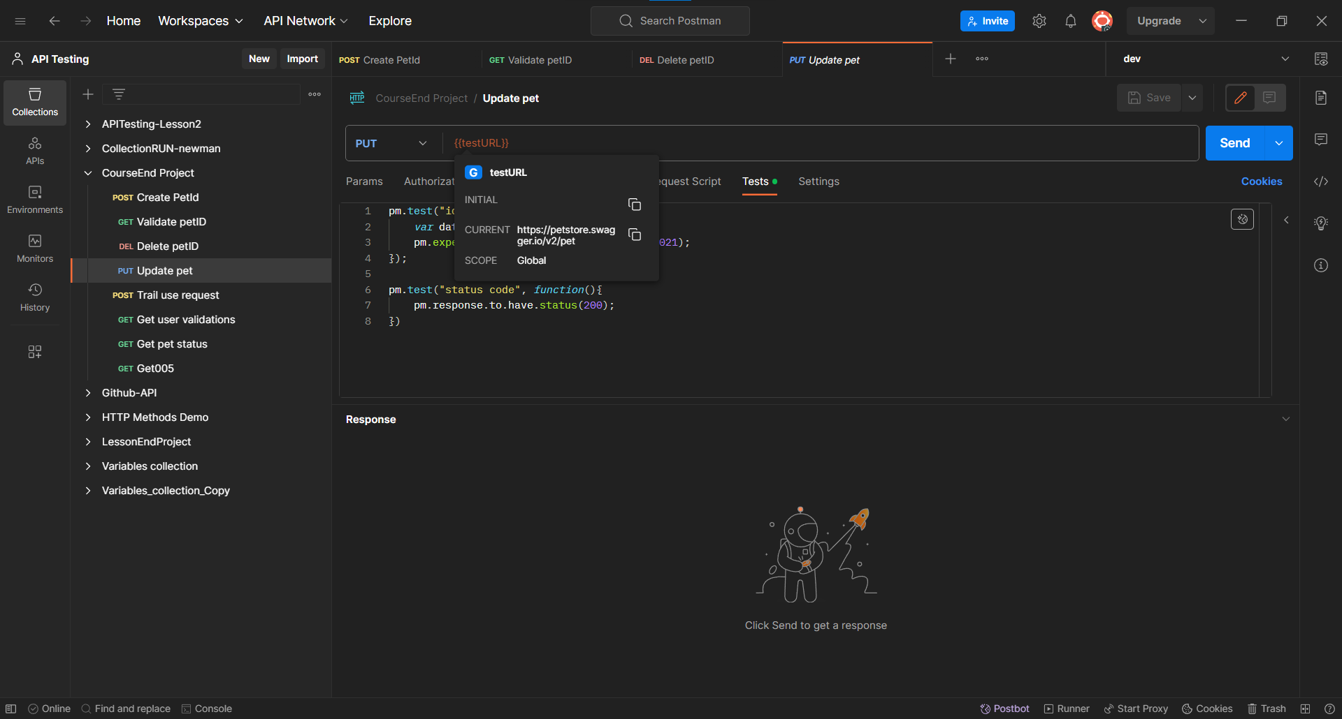

Here testURL sets as the global variable.

To create a Global variable. Click on Environments->click on global section then add the variable. Here added the testURL variable.

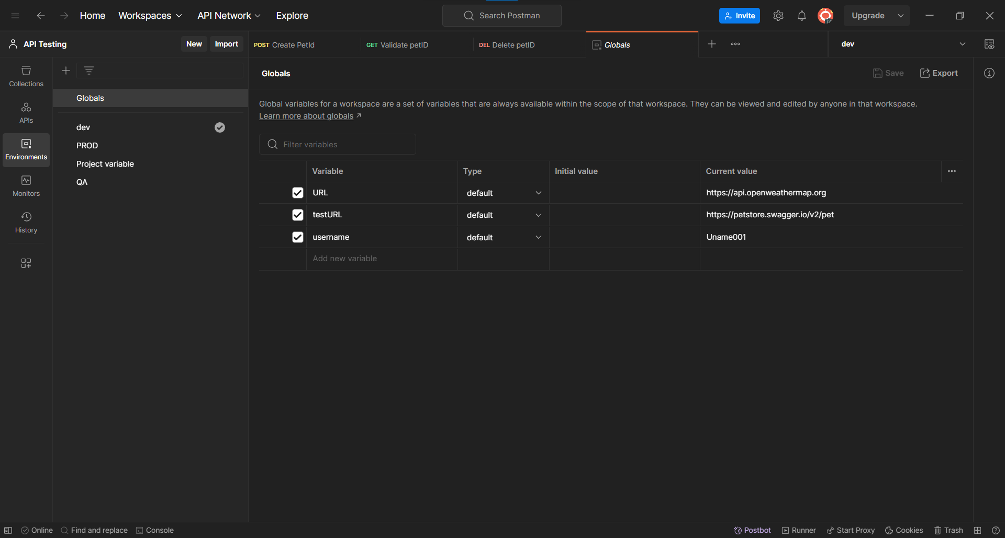

Added the Body section by making the status value as parameterised to update the pet details.

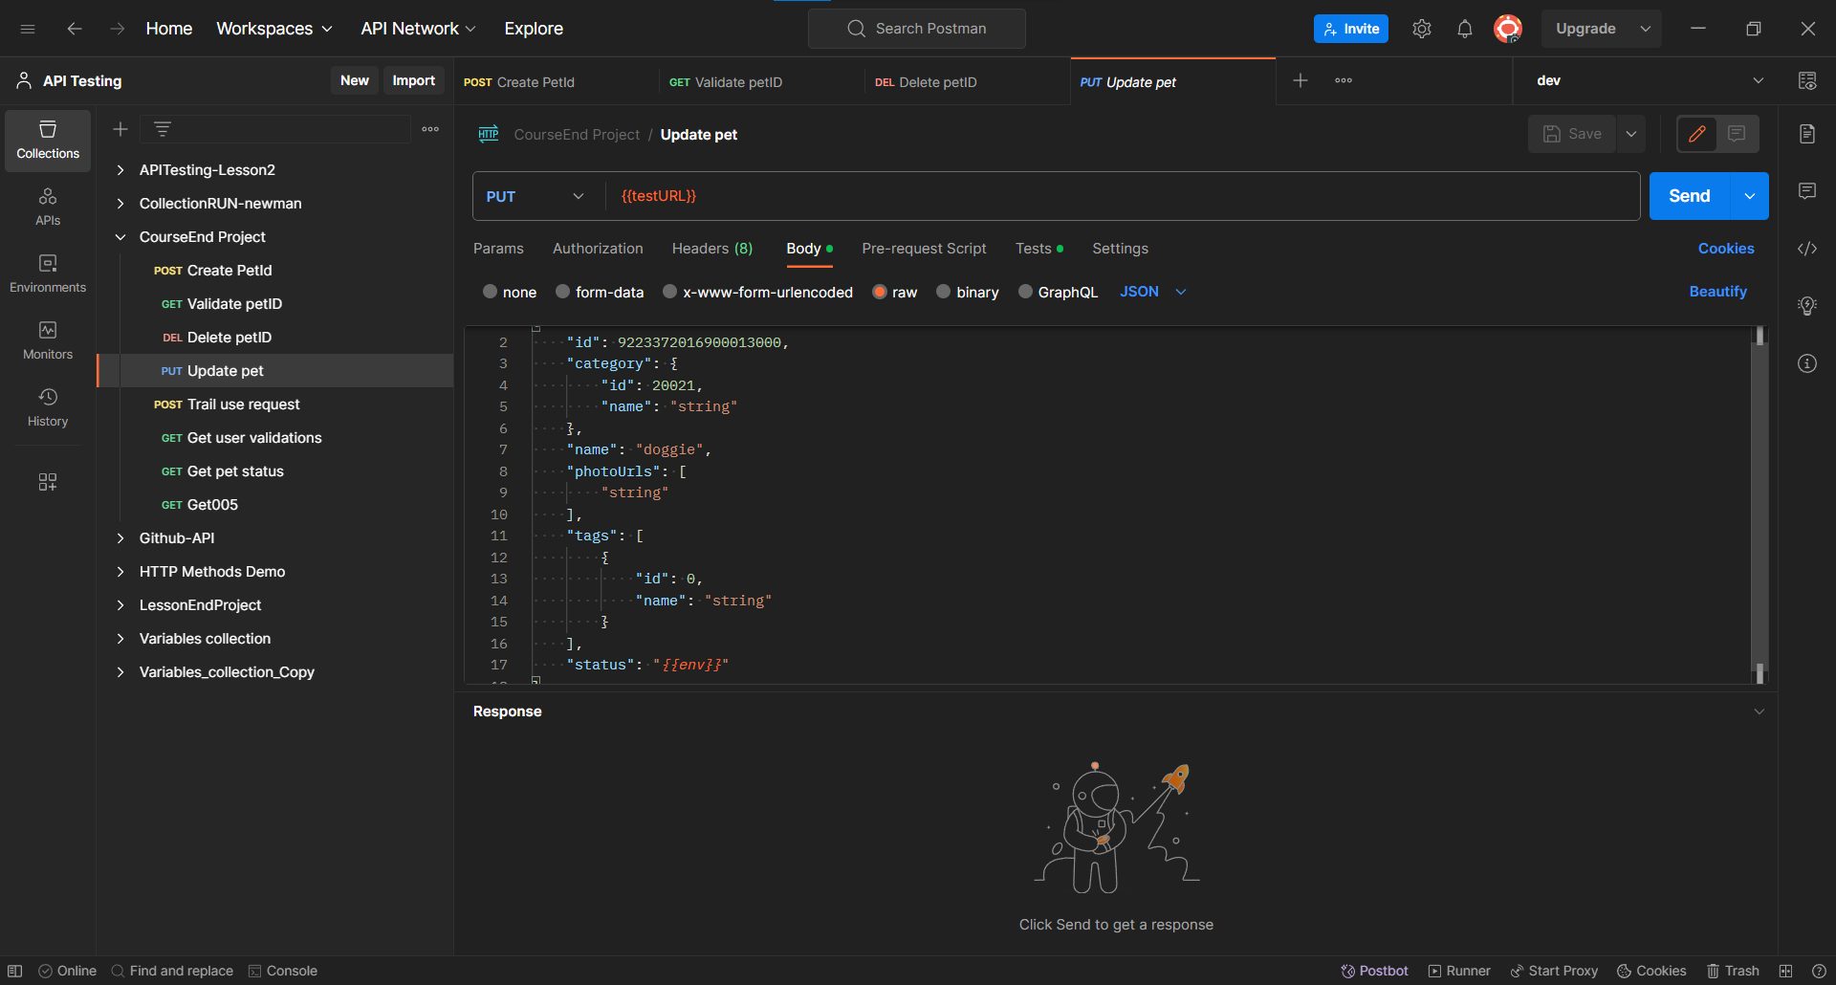

Here we created the three environments with same variable name but different value.

We created a environment with name of dev. And added variable with name as env and values as “available_DEV”.

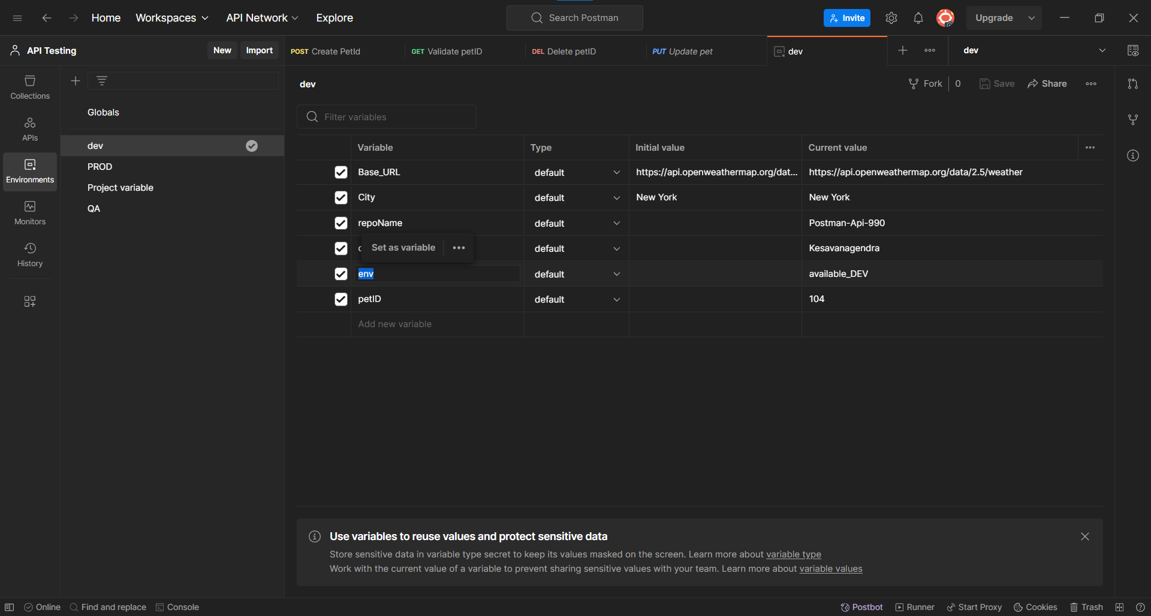

We created a environment with name of PROD. And added variable with name as env and value as “available-PROD”.

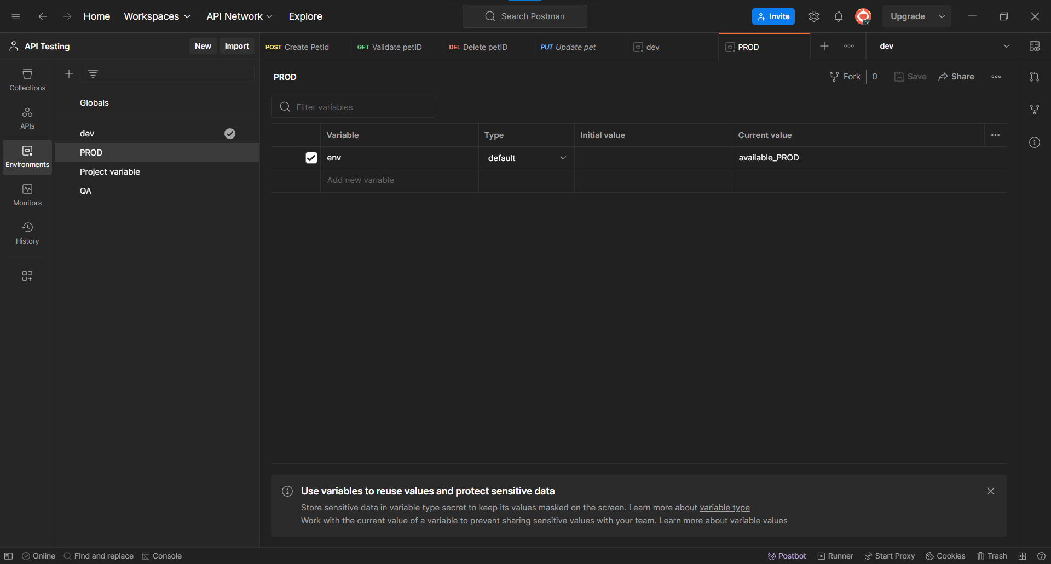

We created a environment with name of PROD. And added variable with name as env and value as “available-PROD”.

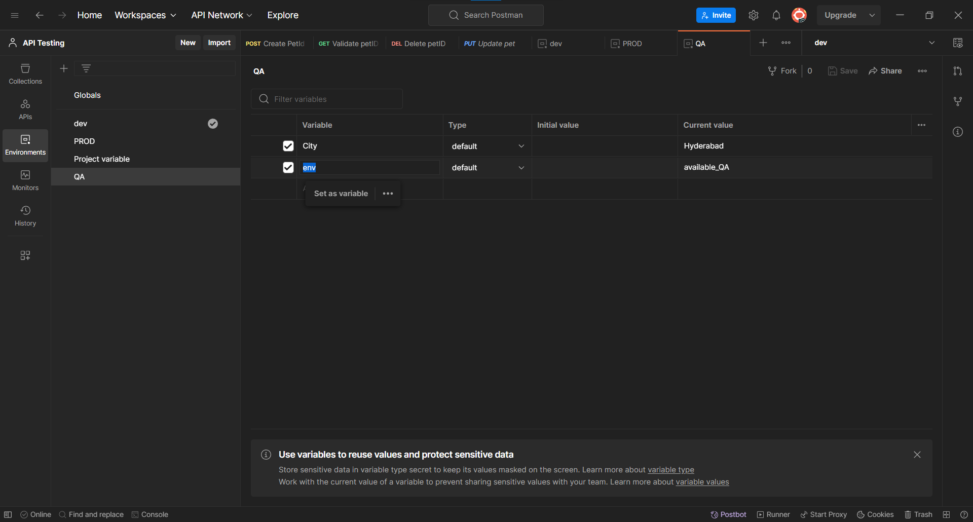

Added the test cases in tests header section.

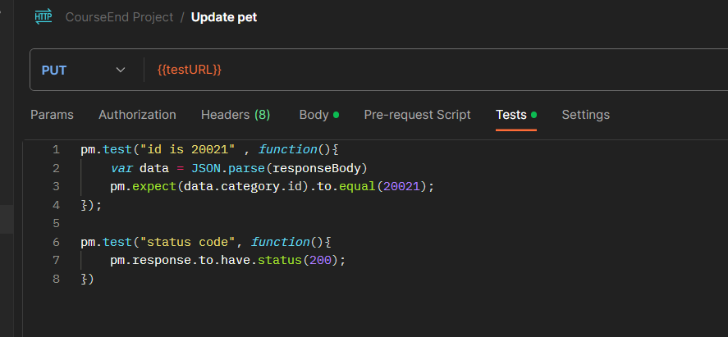

Here selected the dev environment so status variable will be sets as “available_DEV”.

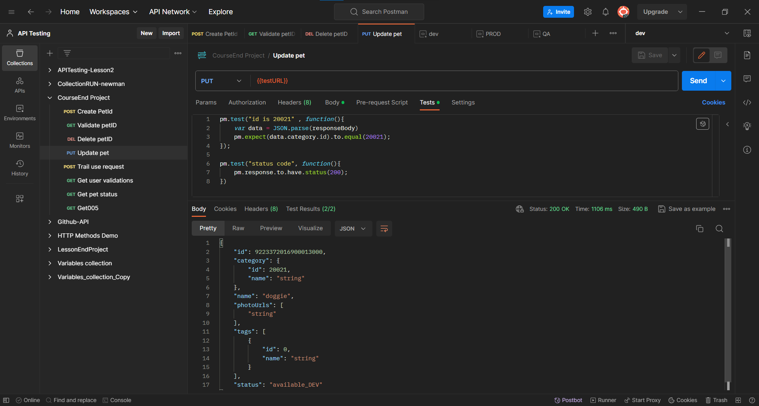

Now changing the environment to the PROD environment. so status variable will be sets as “available_PROD”.

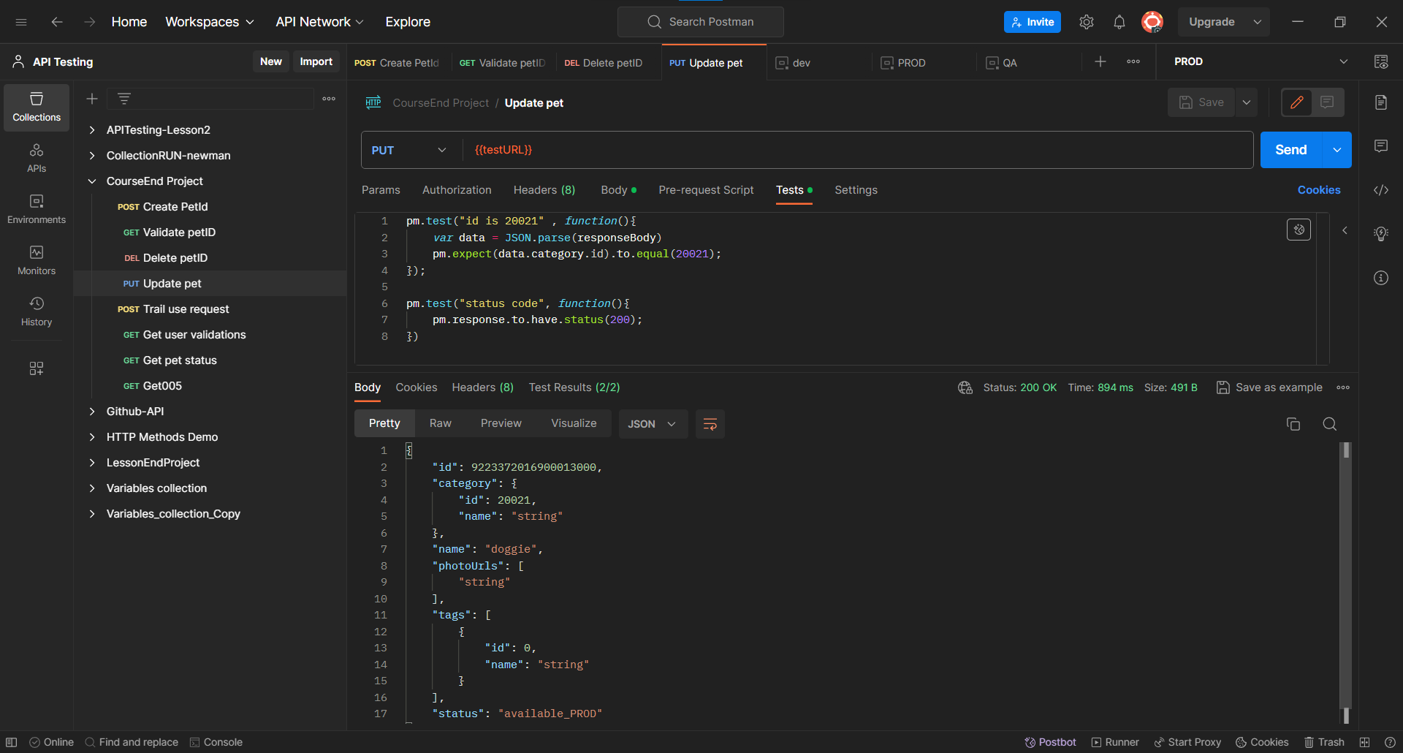

Now changing the environment to the QA environment. so status variable will be sets as “available_QA”.

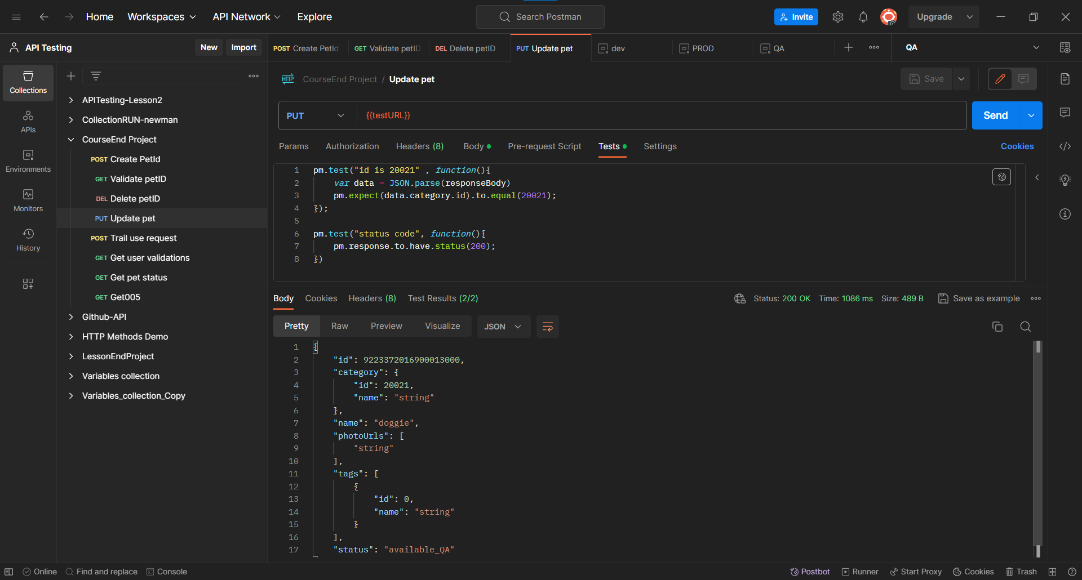

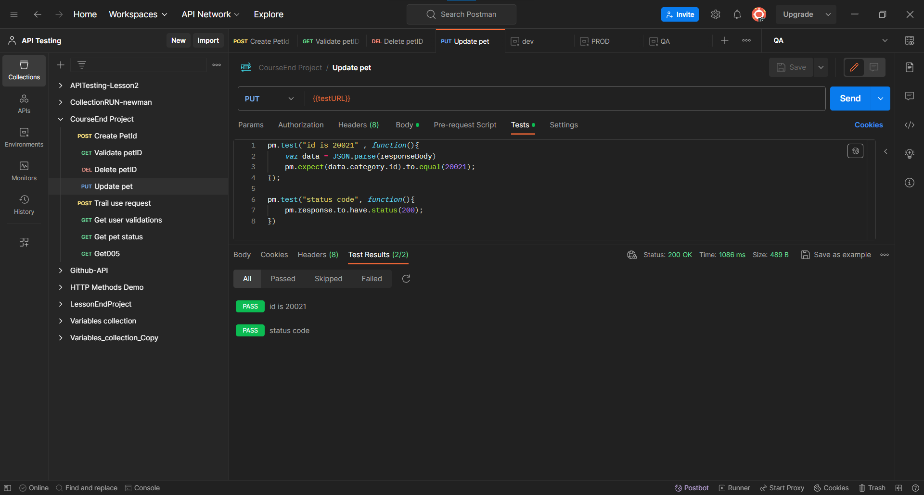

**Postman Assignment 003**

Added the new Request in the same collection. Given the https link in tab and selected the GET method to retrieve the user details.

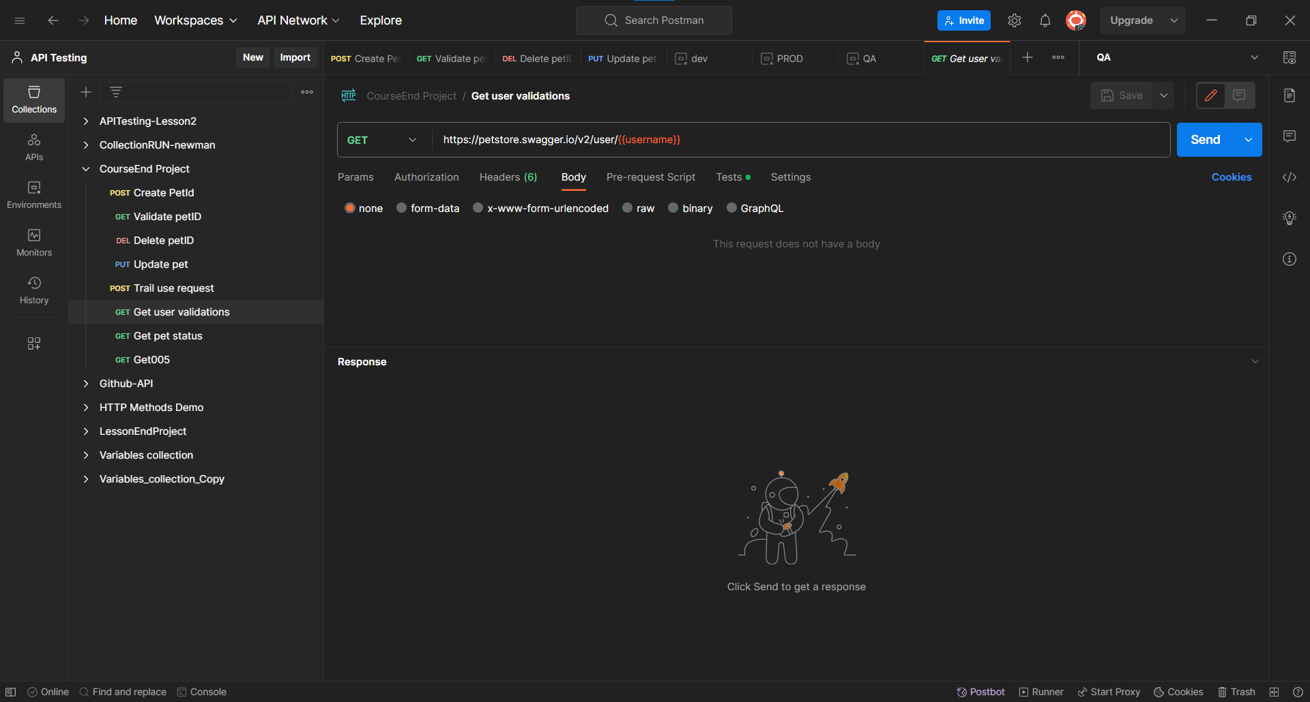

Here Username sets as Global variable.

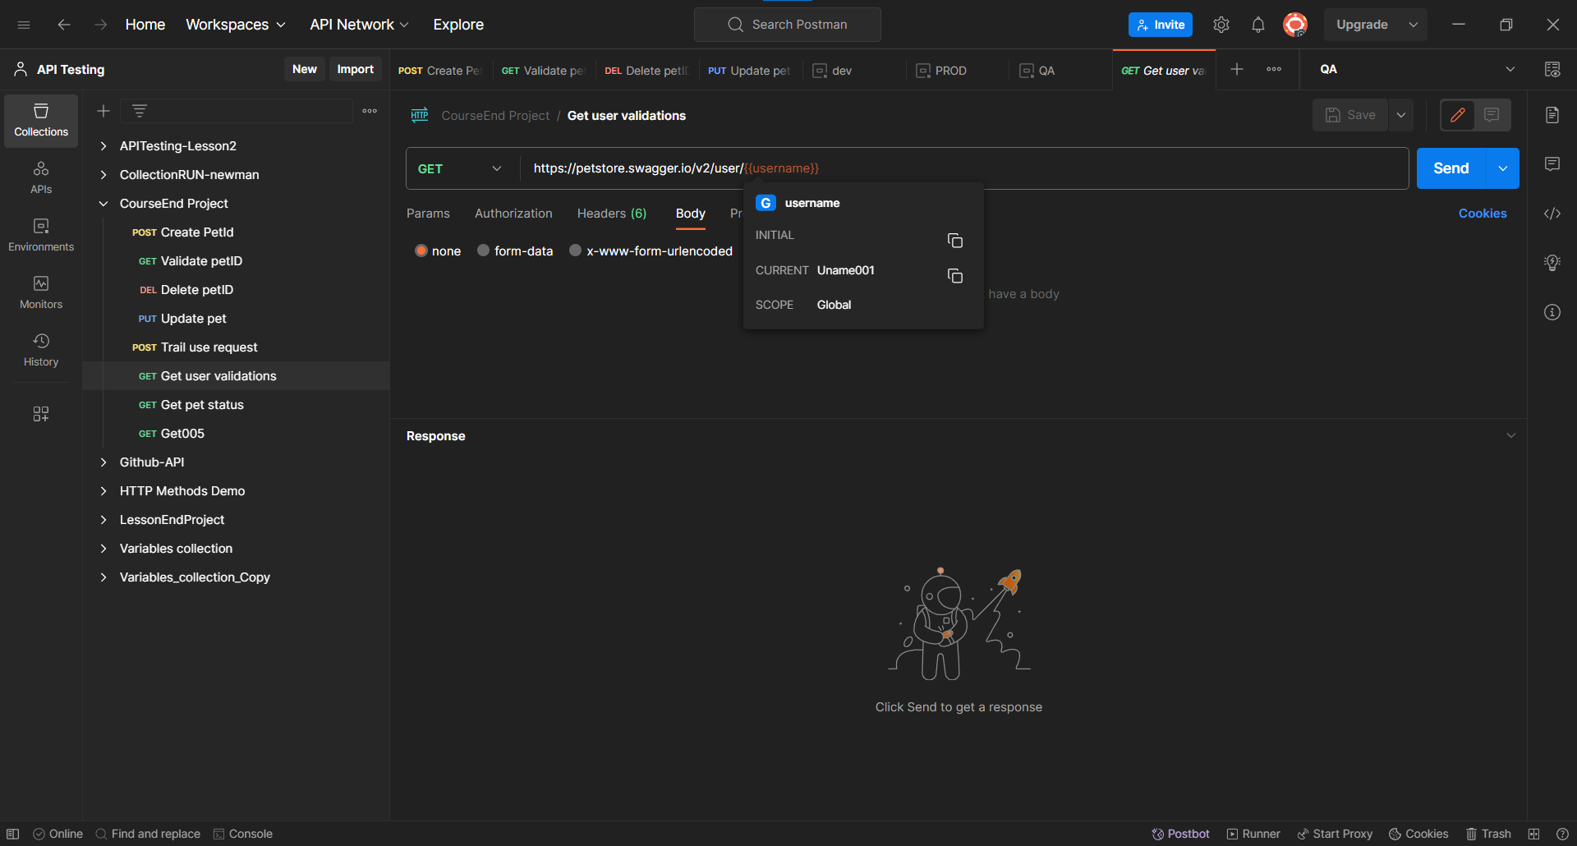

In the Environment section added the variable “username” with values as Uname001

In the global section.

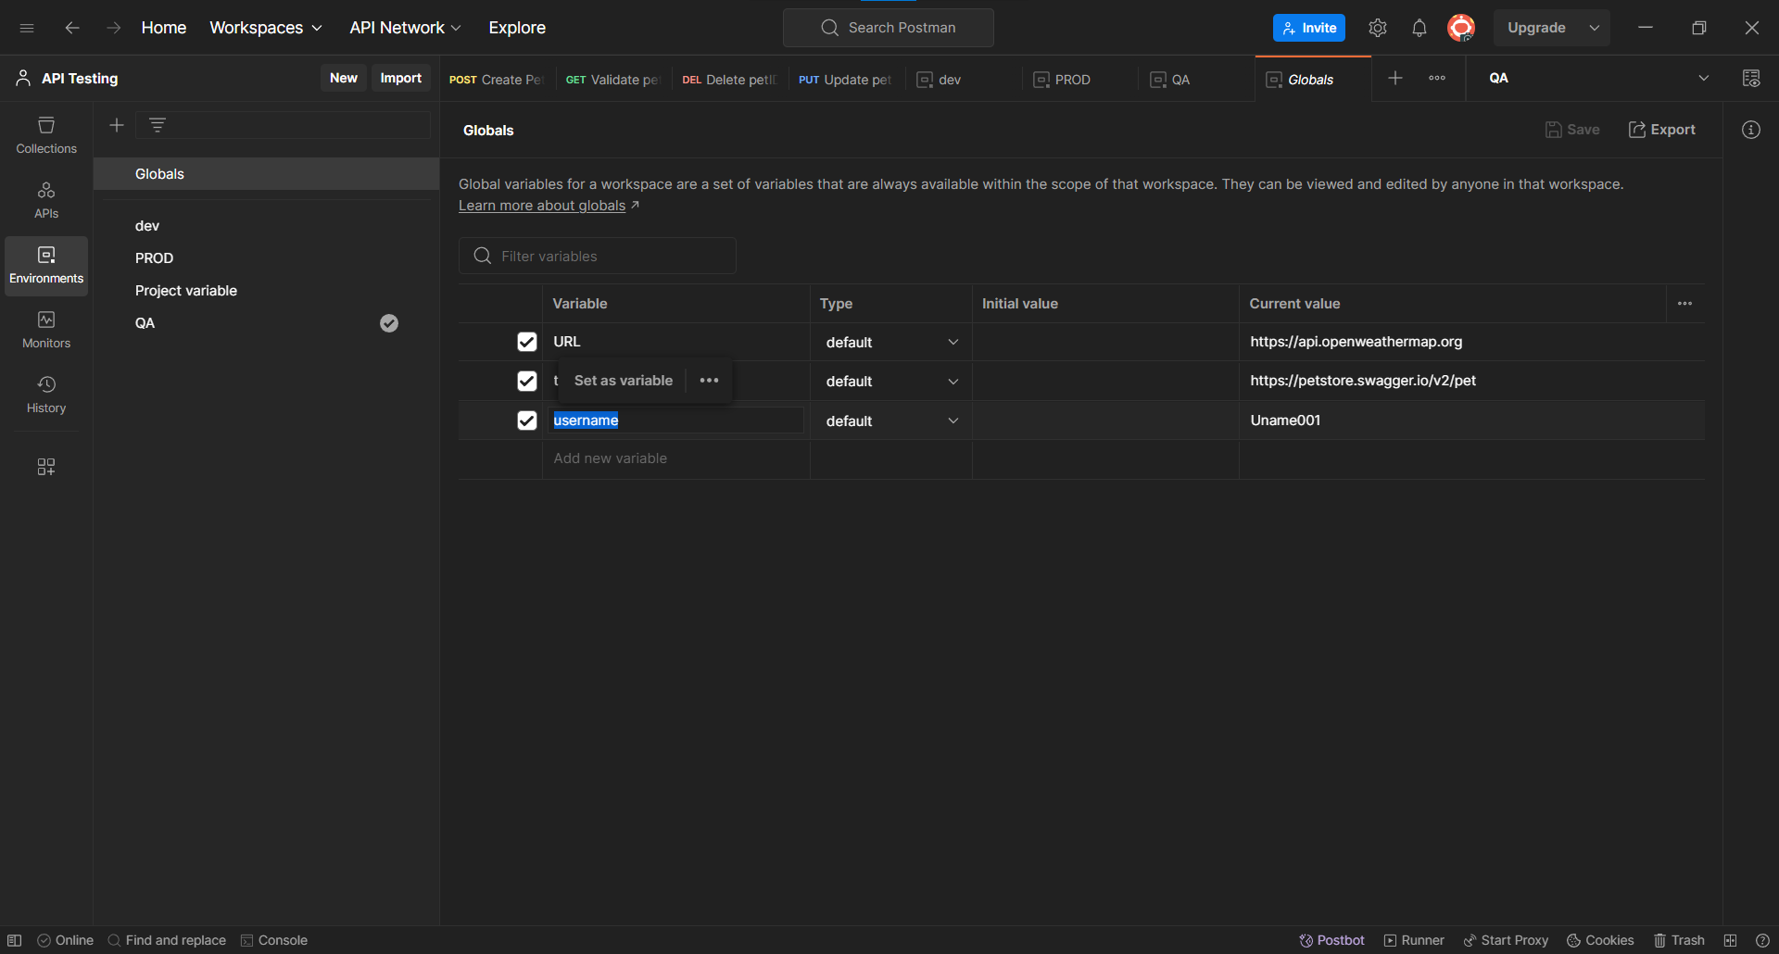

Added the test cases in the tests header section.

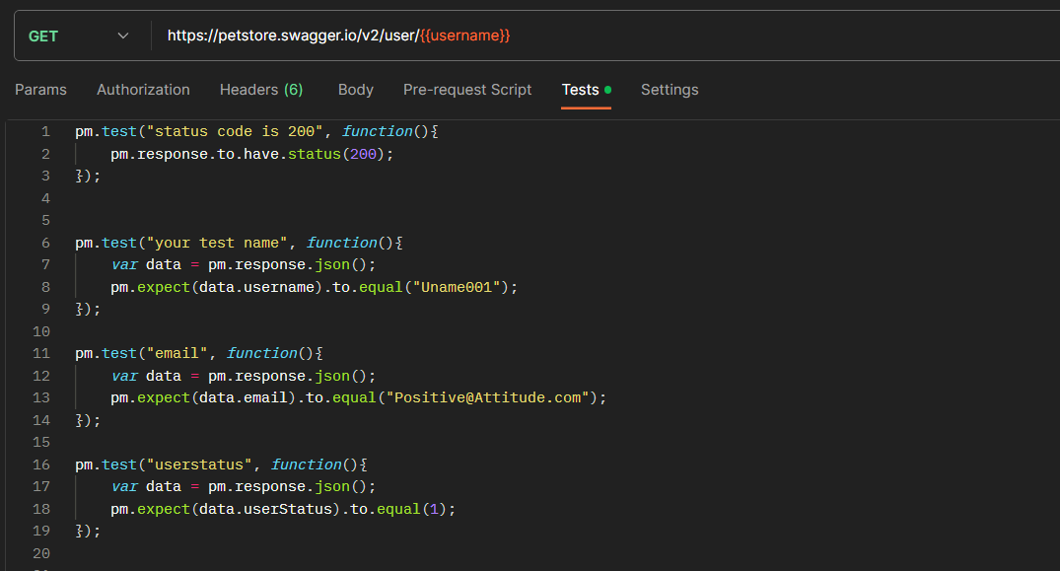

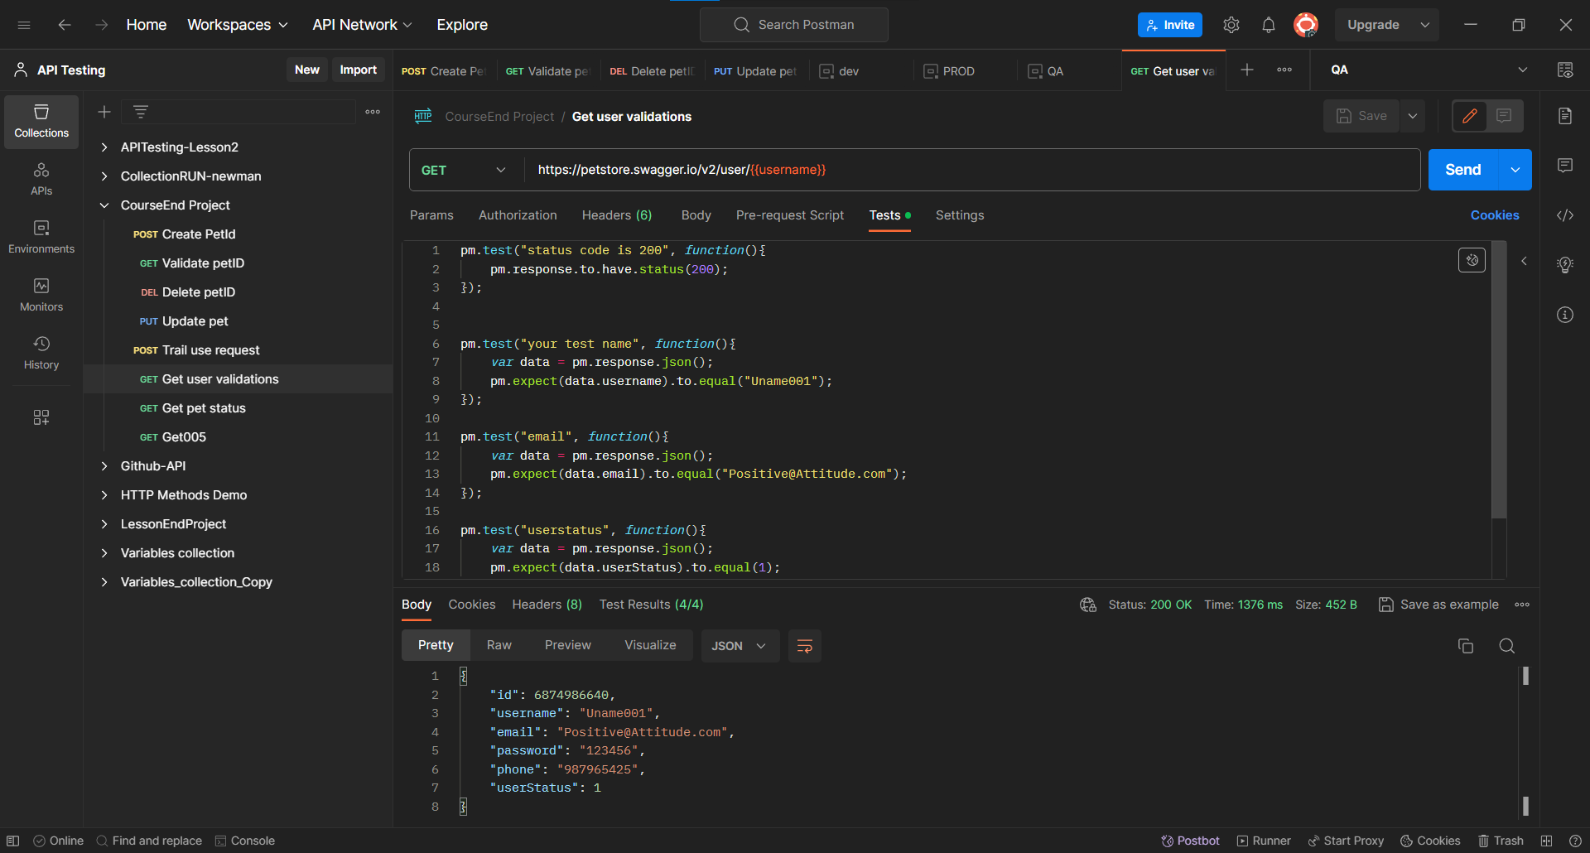

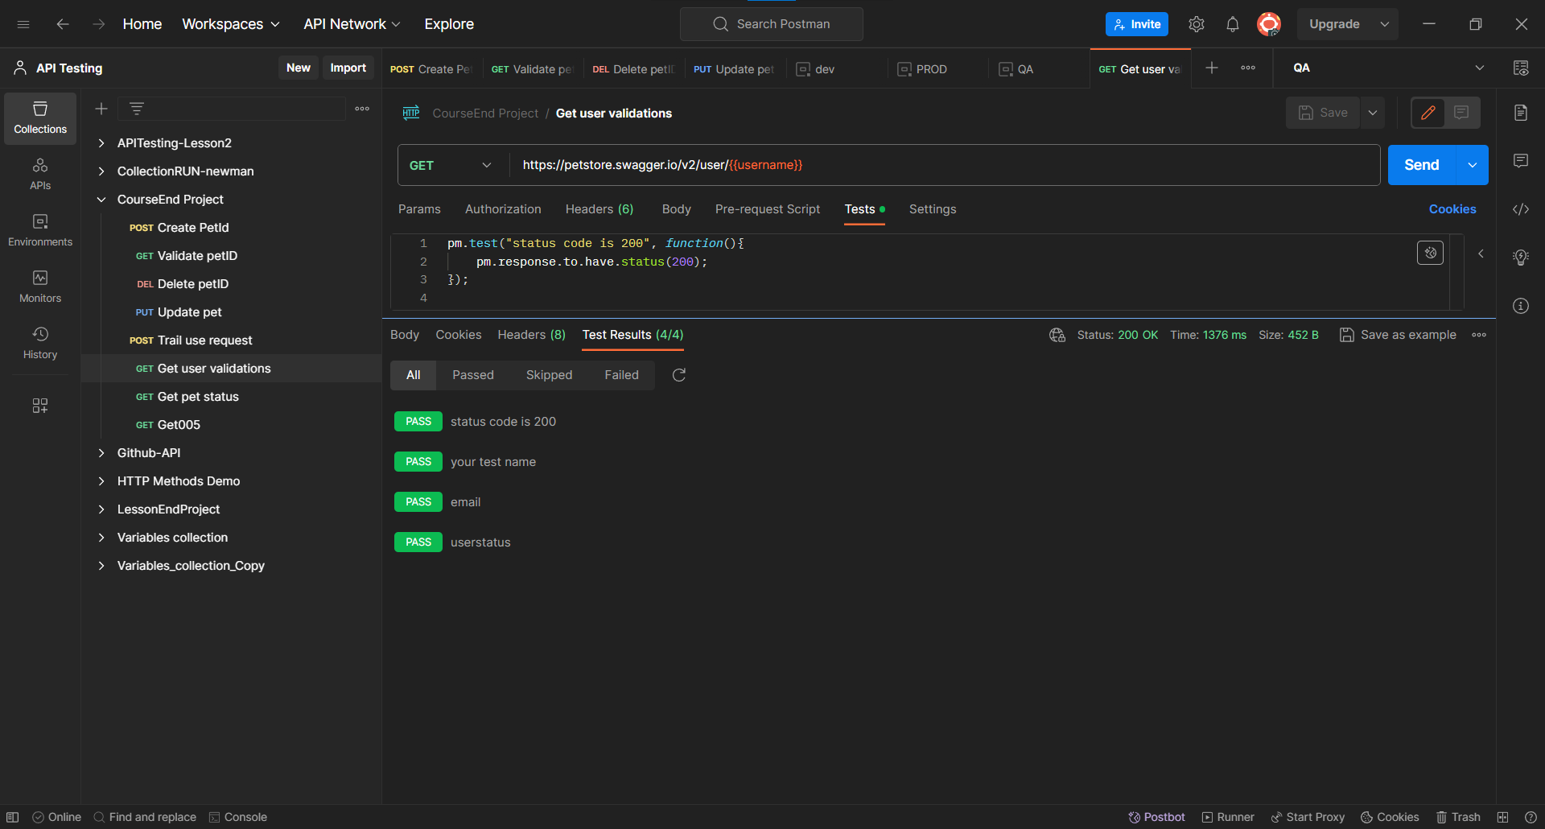

**Postman Assignment 004**

Added the new Request in the same collection. Given the https link in tab and selected the GET method to retrieve the Pet details by status

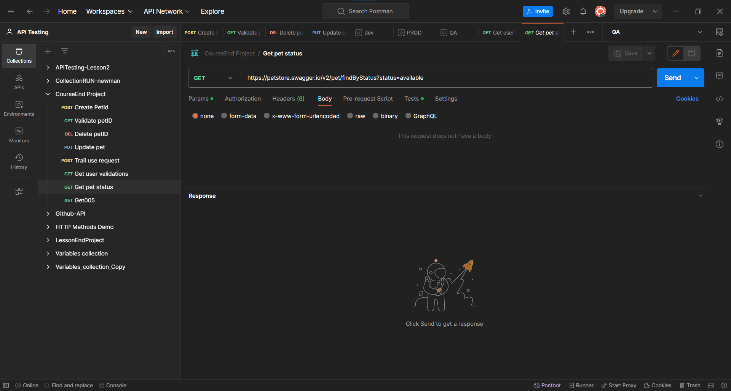

Here the status is parameterised as params parameter.

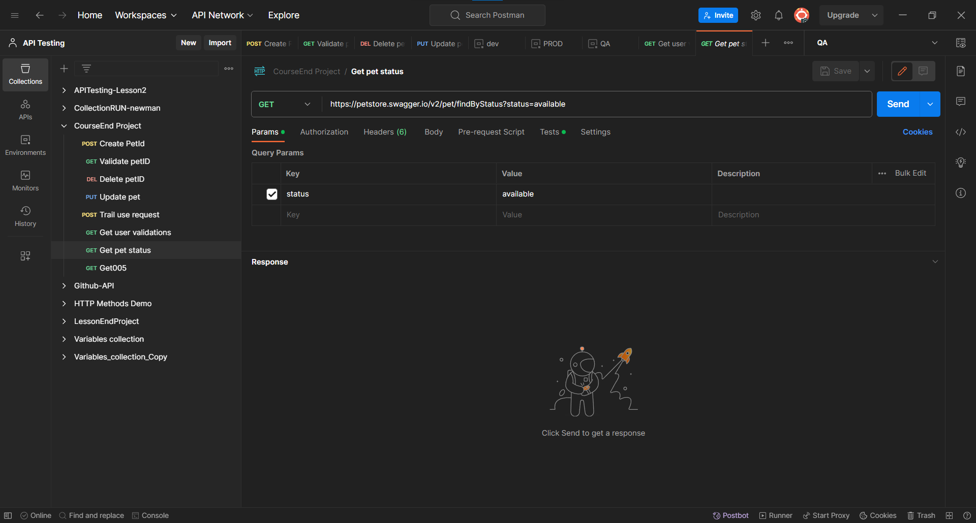

Added the test cases in the tests header section.

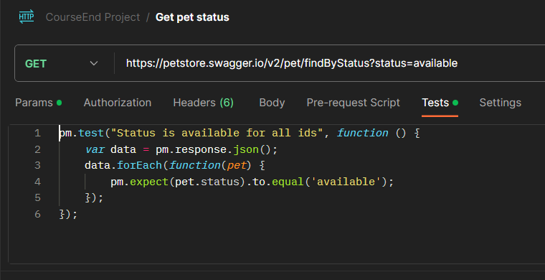

Here we will get the all pets details where pets status is available.

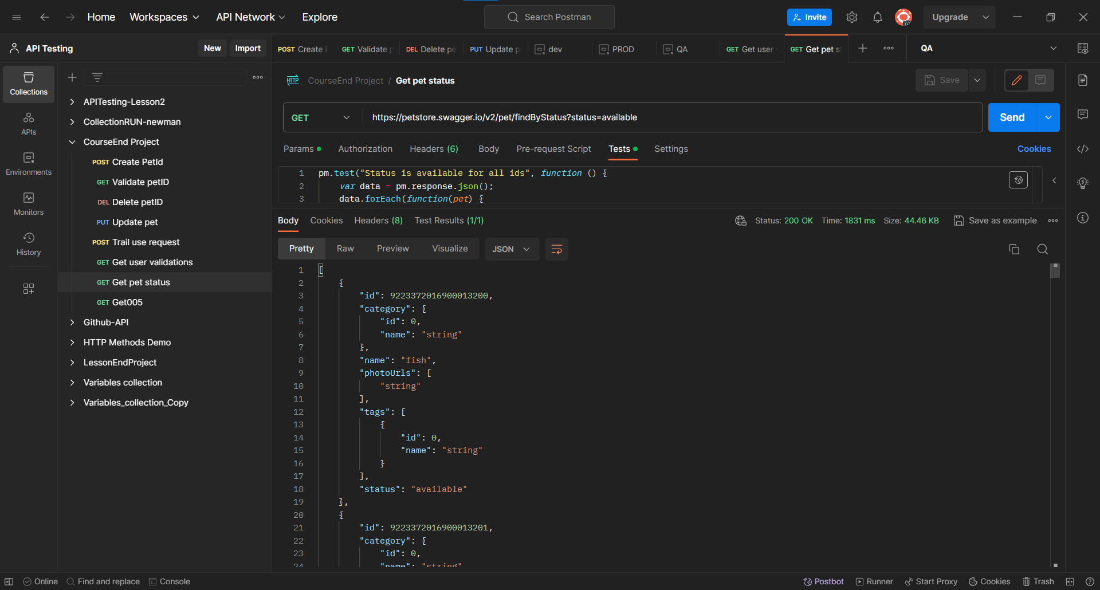

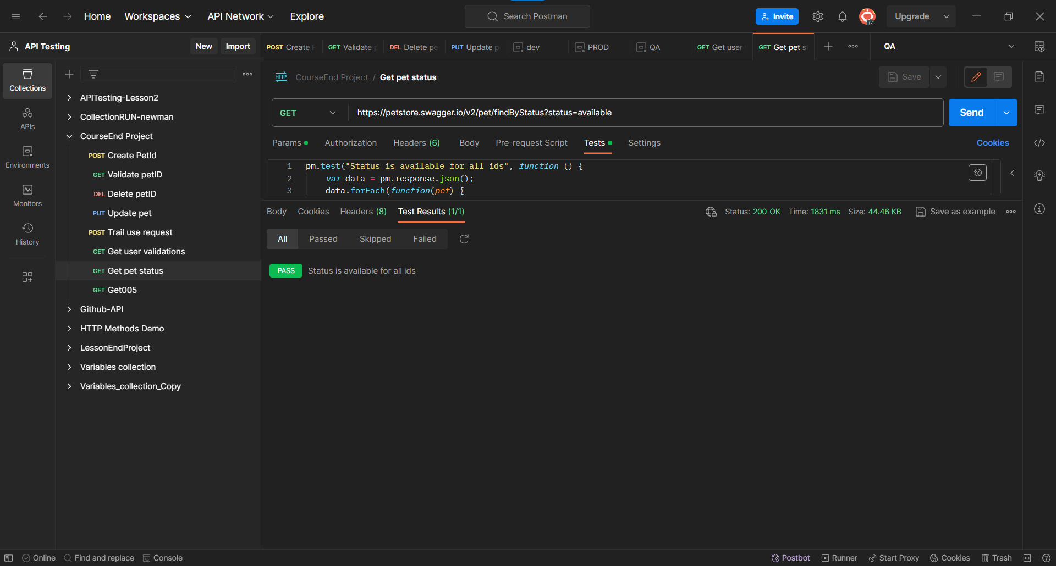

**Postman Assignment 005**

Added the new Request in the same collection. Given the https link in tab and selected the GET method .

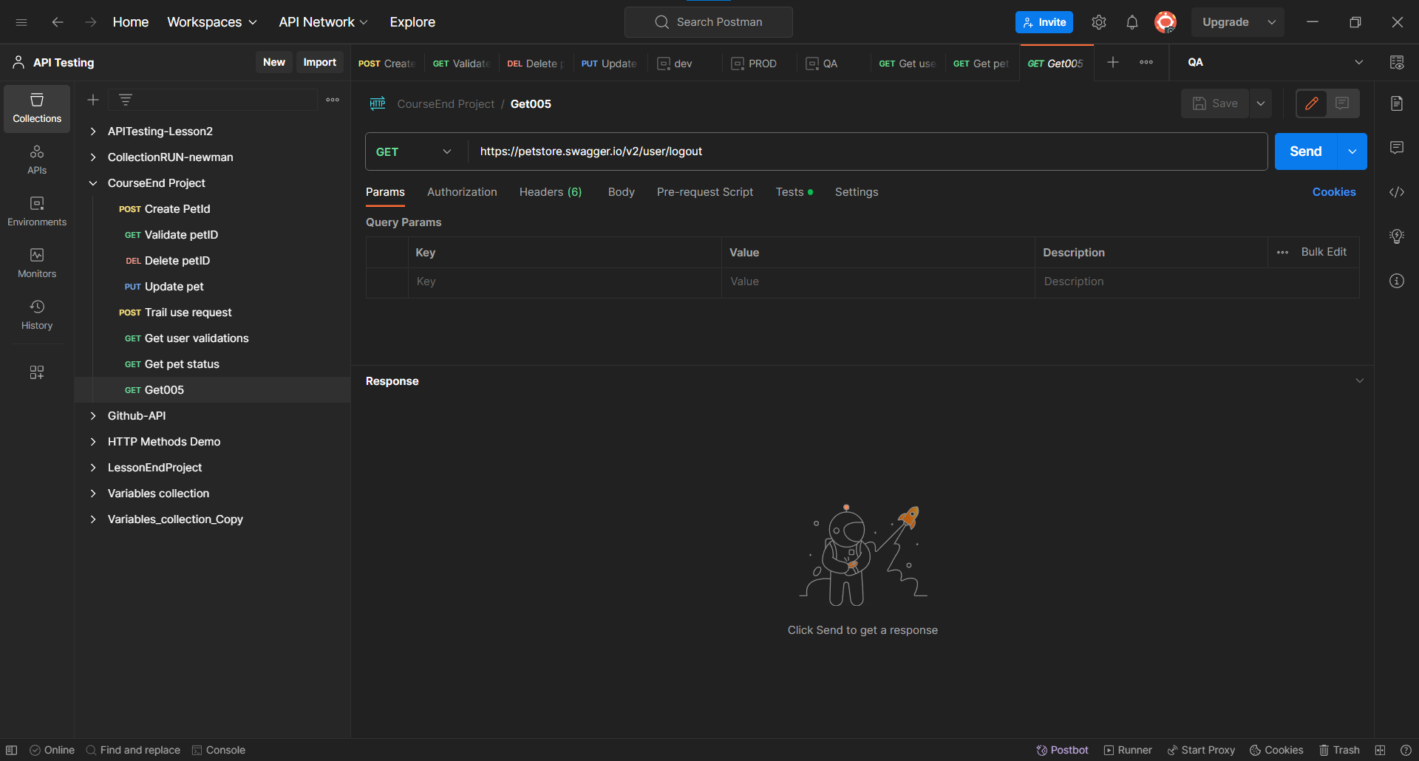

And added the test cases in the test header section.

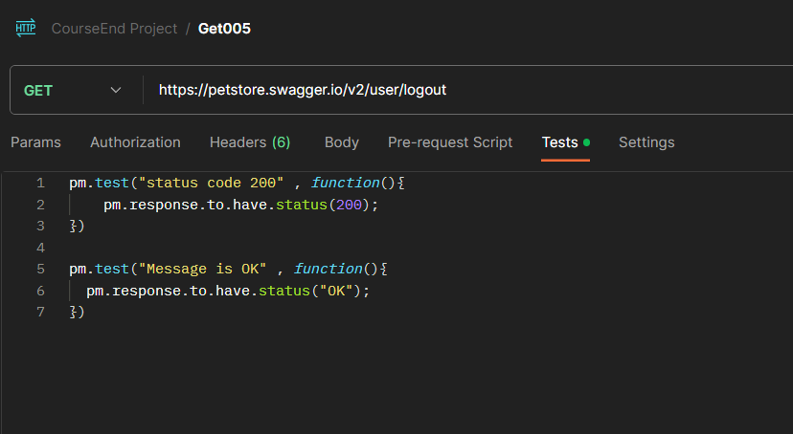

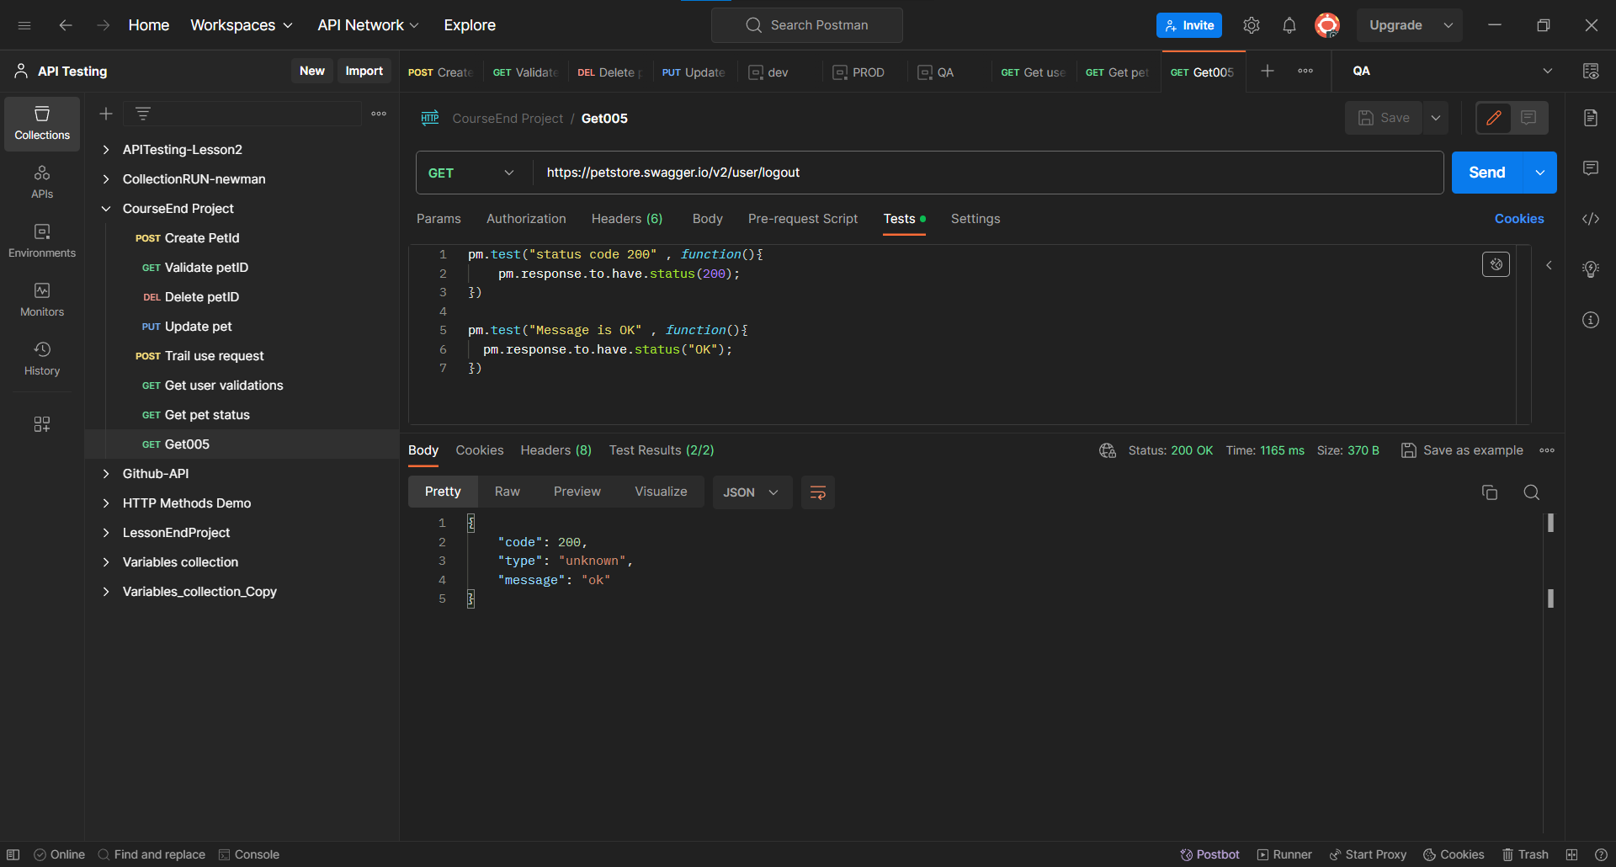

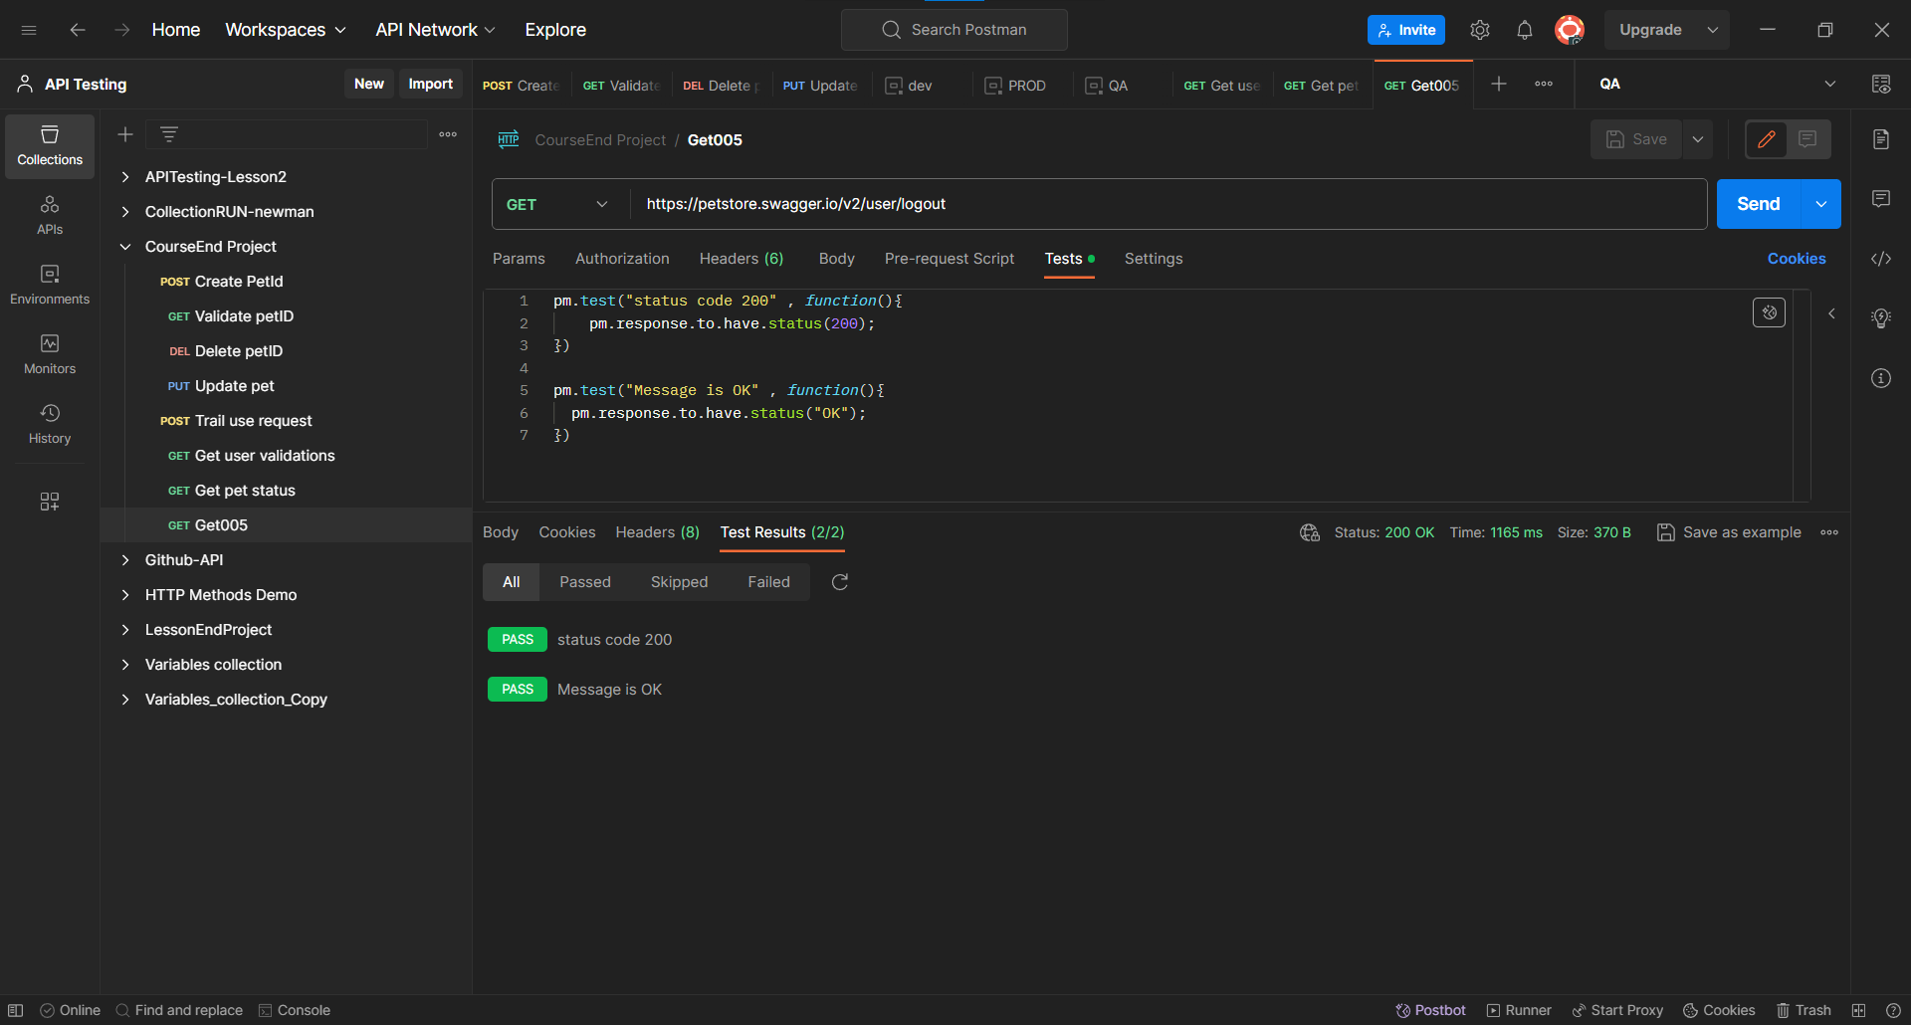

**Rest Assured**

**Rest Assured Assignment 001**

package phaseEndProject;

import java.io.File;

import org.hamcrest.Matchers;

import org.testng.Assert;

import org.testng.annotations.Ignore;

import org.testng.annotations.Test;

import io.restassured.RestAssured;

import io.restassured.http.ContentType;

import io.restassured.response.Response;

public class RestAssuredAss001 {

@Test(priority = '1')

public void petCreation() {

File file = new File("resources/data.json");

RestAssured.given().

baseUri("https://petstore.swagger.io")

.basePath("/v2/pet")

.contentType(ContentType.JSON)

.accept("application/json")

.body(file)

.when().post()

.then().statusCode(200)

.body("id", Matchers.equalTo(344))

.log().all();

}

@Test(priority = '2' , dependsOnMethods = "petCreation")

public void getPetWithID() {

RestAssured.given().

baseUri("https://petstore.swagger.io")

.basePath("/v2/pet/344")

.when().get()

.then().statusCode(200)

.statusLine("HTTP/1.1 200 OK")

.body("status",Matchers.equalTo("available"))

.body("category",Matchers.hasKey("id"))

.log().all();

}

@Test(priority = '3' , dependsOnMethods = "getPetWithID")

public void deletePetWithID() {

RestAssured.given()

.baseUri("https://petstore.swagger.io")

.basePath("/v2/pet/344")

.when().delete()

.then().statusCode(200).log().all()

.body("code", Matchers.equalTo(200))

.body("type", Matchers.equalTo("unknown"))

.body("message", Matchers.equalTo("344"));

}

}

Created a resource folder and added the body of json file.

{

"id": 344,

"category": {

"id": 0,

"name": "string"

},

"name": "Doggie",

"photoUrls": [

"string"

],

"tags": [

{

"id": 0,

"name": "string"

}

],

"status": "available"

}

**Output:-**

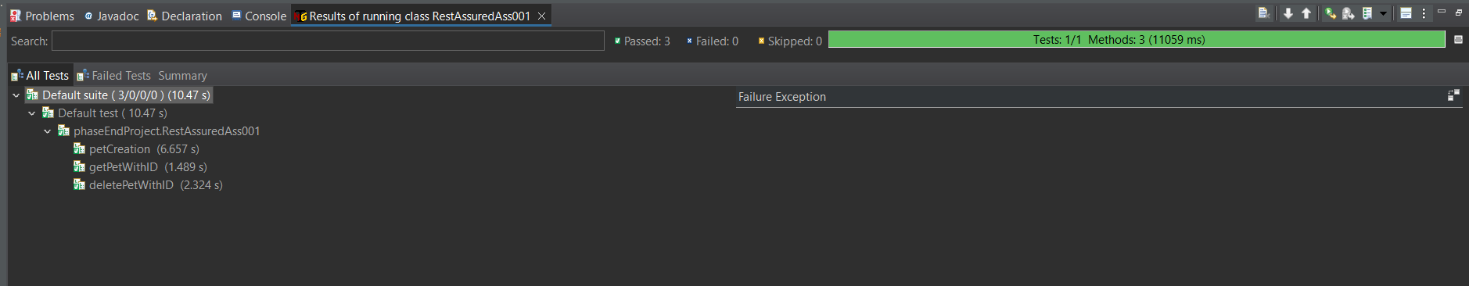

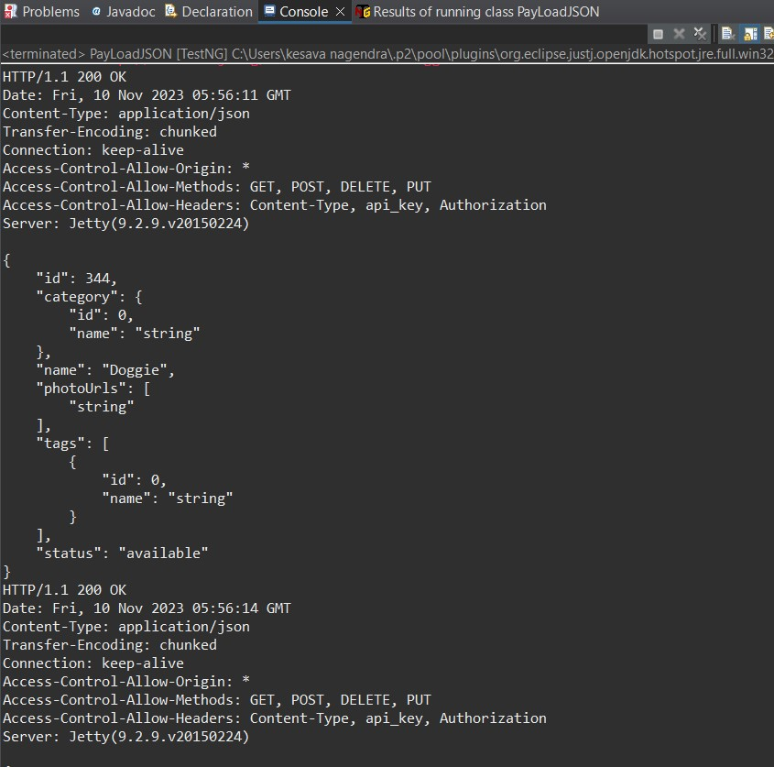

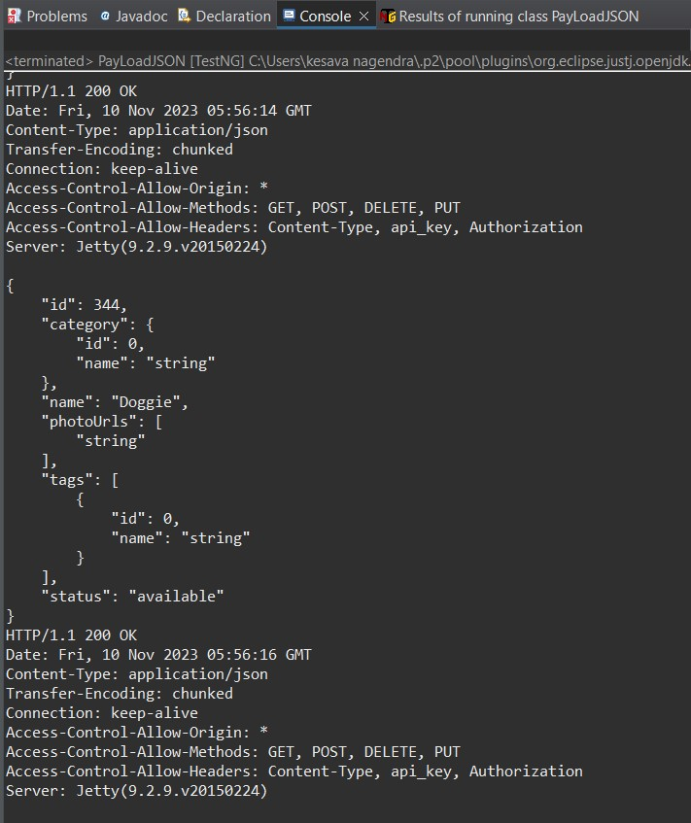

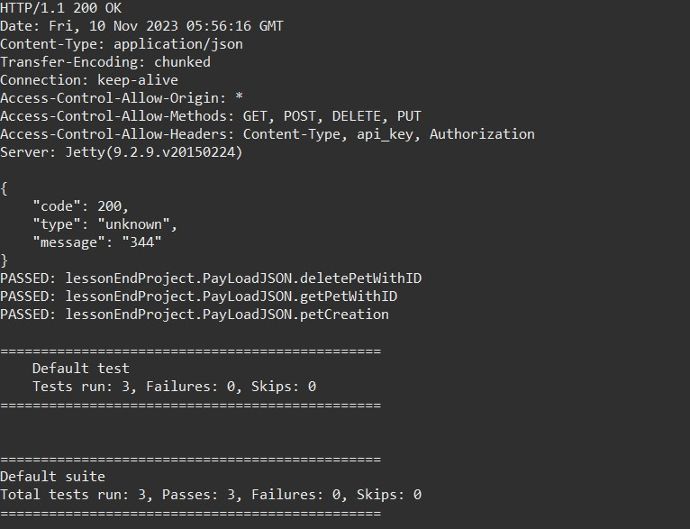

**Rest Assured Assignment 002**

package phaseEndProject;

import java.io.File;

import org.apache.logging.log4j.LogManager;

import org.apache.logging.log4j.Logger;

import org.hamcrest.Matchers;

import org.testng.annotations.Test;

import io.restassured.RestAssured;

import io.restassured.http.ContentType;

public class RestAssuredAss002 {

Logger logger = LogManager.getLogger(RestAssuredAss002.class);

@Test(priority = '1')

public void petCreation() {

logger.info("Course End project - Assignment002 - POST request");

File file = new File("resources/dataput002.json");

RestAssured.given().

baseUri("https://petstore.swagger.io")

.basePath("/v2/pet")

.contentType(ContentType.JSON)

.accept("application/json")

.body(file)

.when().post()

.then().statusCode(200)

.body("id", Matchers.equalTo(344))

.log().all();

logger.trace("The status code is checked");

logger.trace("Id has been captured and validated");

}

@Test(priority='2')

public void assignment002Put()

{

File file = new File("resources/dataput002.json");

int id = RestAssured.given()

.baseUri("https://petstore.swagger.io/v2/pet/")

.contentType(ContentType.JSON)

.body(file)

.when()

.post()

.then()

.statusCode(200)

.log().all()

.body("status", Matchers.equalTo("available_QA"))

.extract().path("id");

System.out.println(id);

}

}

Added the resource folder then added the body of json file.

{

"id": 344,

"category": {

"id": 0,

"name": "string"

},

"name": "Doggie",

"photoUrls": [

"string"

],

"tags": [

{

"id": 0,

"name": "string"

}

],

"status": "available_QA"

}

**Output:-**

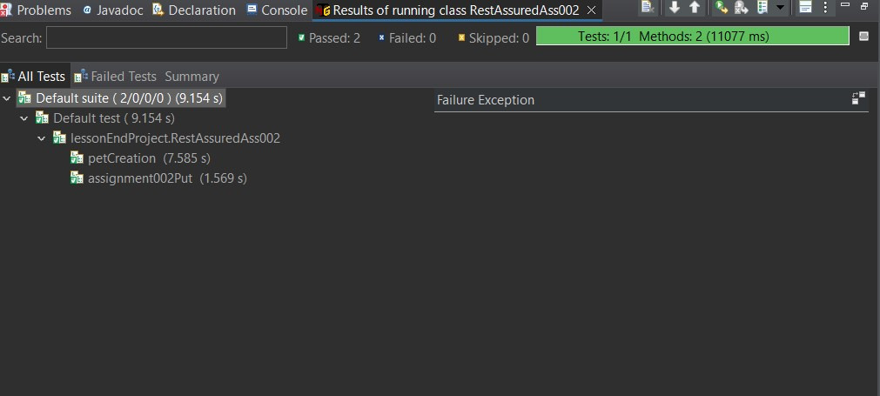

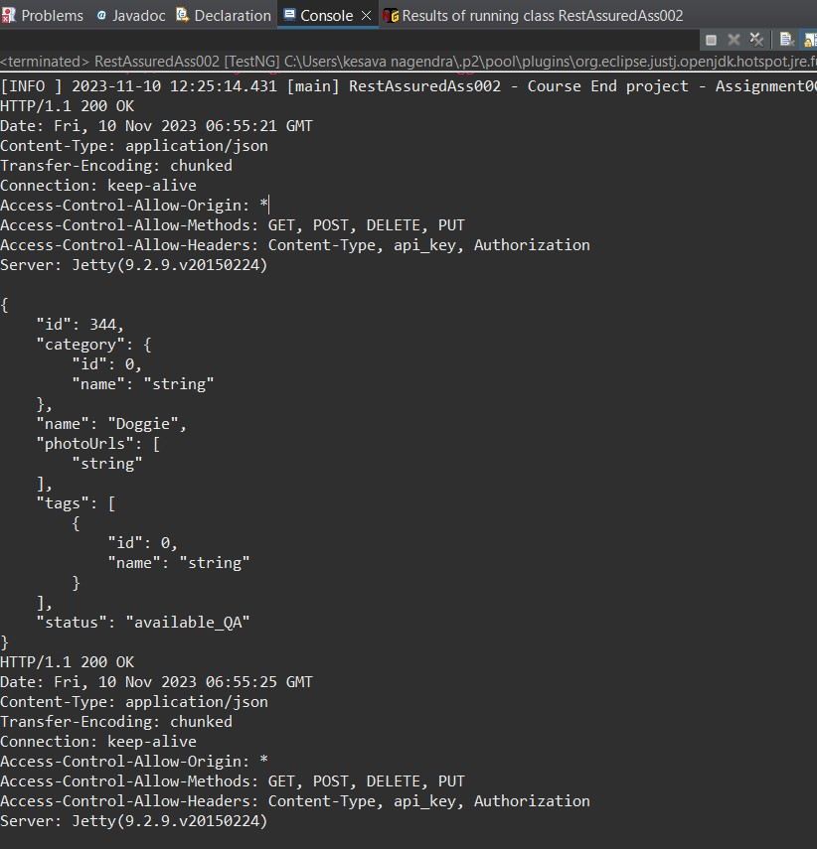

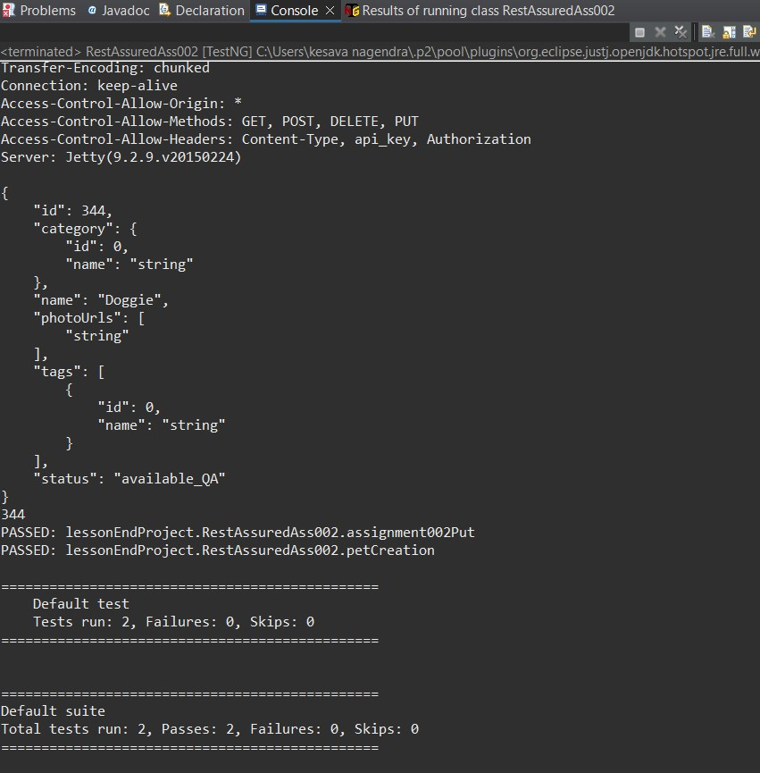

**Rest Assured Assignment 003**

package phaseEndProject;

import static io.restassured.RestAssured.given;

import static org.hamcrest.Matchers.equalTo;

import org.testng.annotations.Test;

public class RestAssuredAss003 {

@Test()

public void validateResponsebodyequalItems() {

given().baseUri("https://petstore.swagger.io")

.basePath("/v2/user/Uname001")

.when().get()

.then().statusCode(200)

.log().all()

.body("username" , equalTo("Uname001"),

"email",equalTo("Positive@Attitude.com"),

"userStatus" , equalTo(1));

}

}

**Output:-**

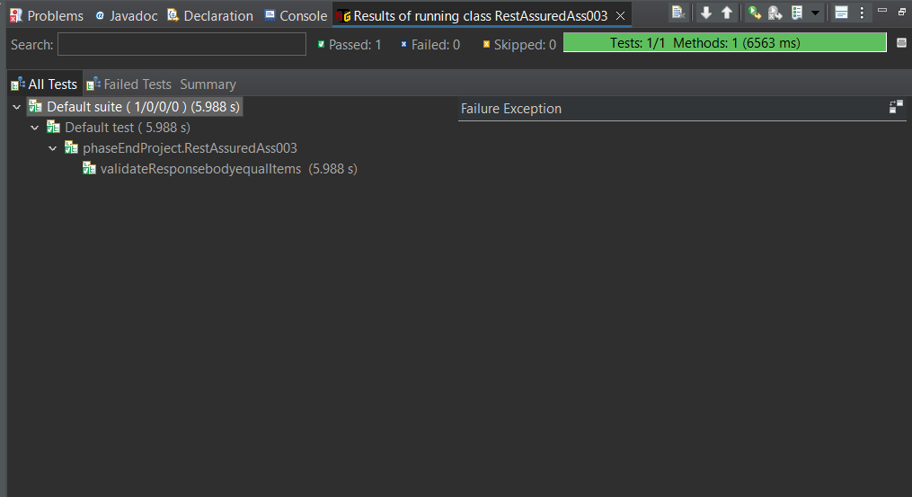

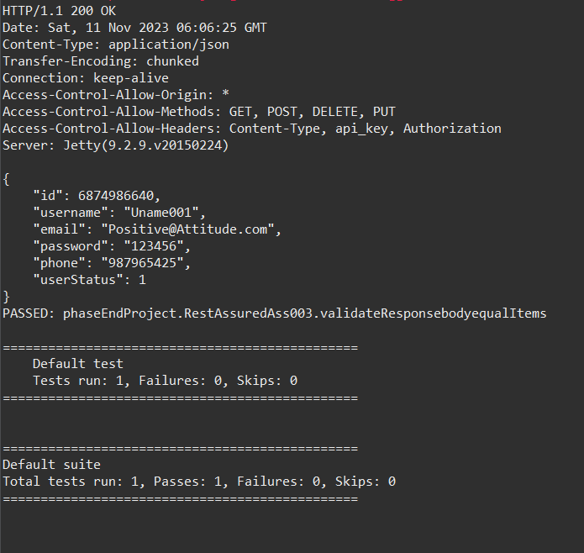

**Rest Assured Assignment 004**

package phaseEndProject;

import org.hamcrest.Matchers;

import org.testng.annotations.Test;

import io.restassured.RestAssured;

public class RestAssuredAss004 {

@Test

public void authenticate() {

String username = "Uname001";

String password = "@tt!tude";

RestAssured.given()

.baseUri("https://petstore.swagger.io")

.basePath("/v2/user/login")

.auth().preemptive().basic(username, password)

.param("grant_type", "client_credentials")

.when().get()

.then().statusCode(200)

.body("message", Matchers.containsString("logged in user session"))

.log().all();

}

}

**Output:-**

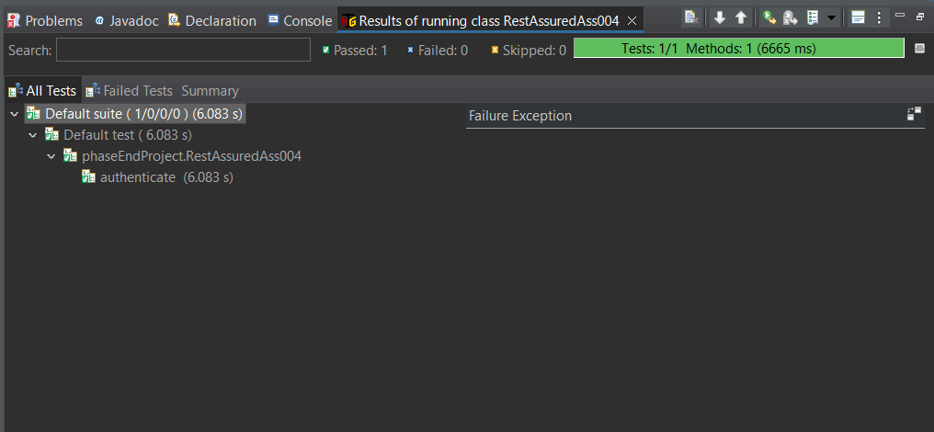

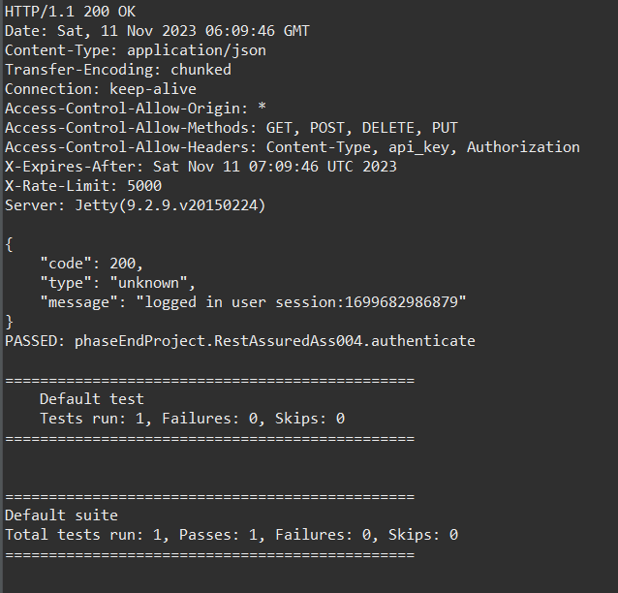

**Rest Assured Assignment 005**

package phaseEndProject;

import org.testng.annotations.Test;

import io.restassured.RestAssured;

public class RestAssuredAss005 {

@Test

public void petFindByStatus() {

RestAssured.given()

.baseUri("https://petstore.swagger.io")

.basePath("/v2/pet/findByStatus")

//.param("status", "available")

//.queryParam("status", "pending")

.queryParam("status", "sold")

.when().get()

.then().statusCode(200)

.log().all();

}

}

**Output:-**

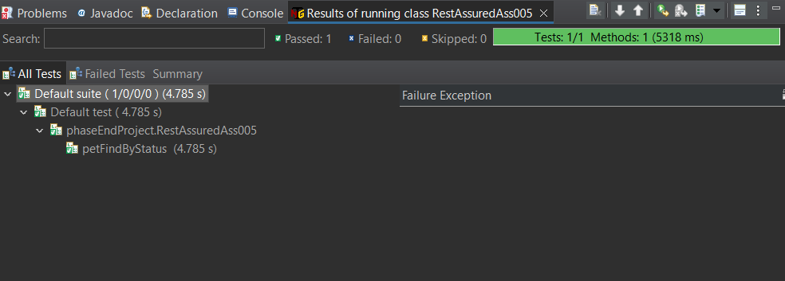

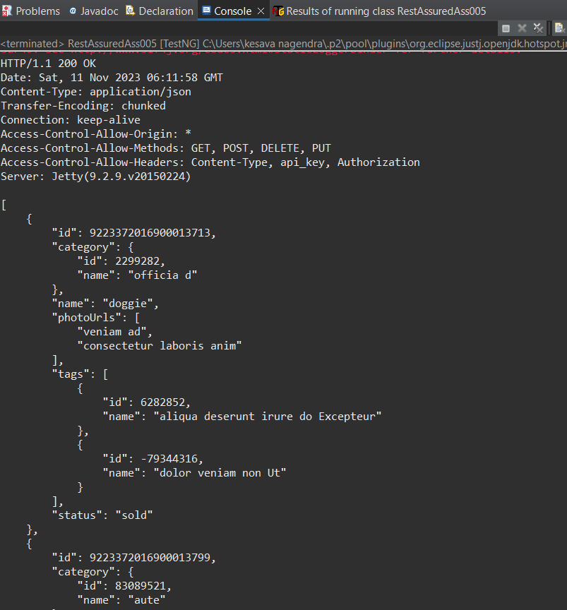

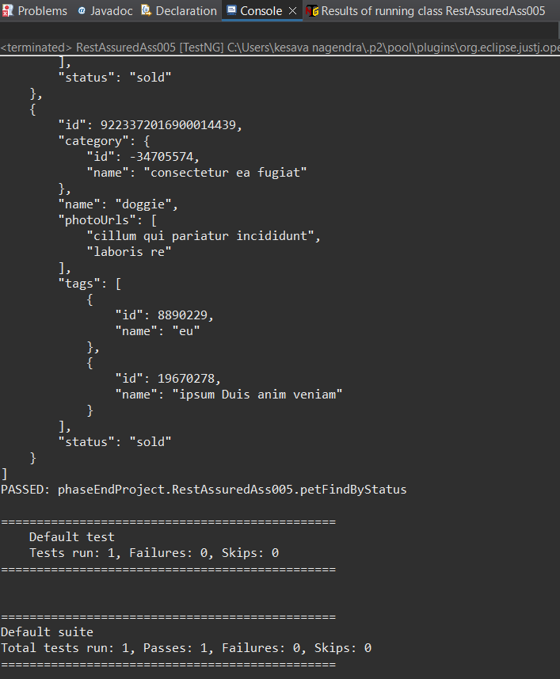

**Rest Assured Assignment 006**

package phaseEndProject;

import org.hamcrest.Matchers;

import org.testng.annotations.Test;

import io.restassured.RestAssured;

public class RestAssuredAss006 {

@Test

public void assignment006Logout()

{

RestAssured.given()

.baseUri("https://petstore.swagger.io/v2/user/logout")

.when()

.get()

.then()

.statusCode(200)

.log().all()

.body("code", Matchers.equalTo(200))

.body("type", Matchers.equalTo("unknown"))

.body("message", Matchers.equalTo("ok"));

}

}

**Output:-**

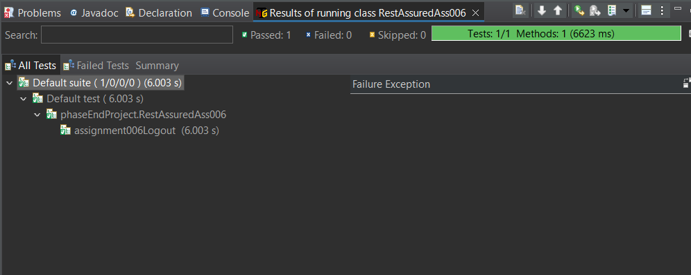

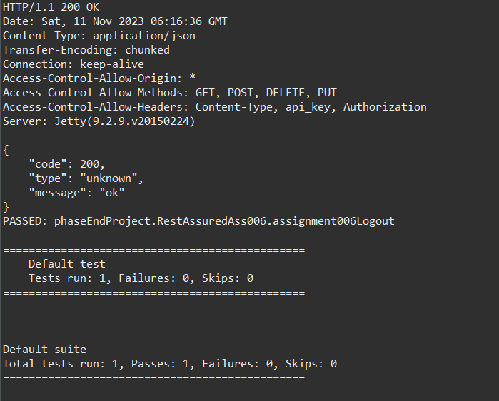

**JMeter**

**JMeter Assignment 001**

In the Test plan added the Thread Group.

Right click on Test Plan->Add->users->Thread Group.

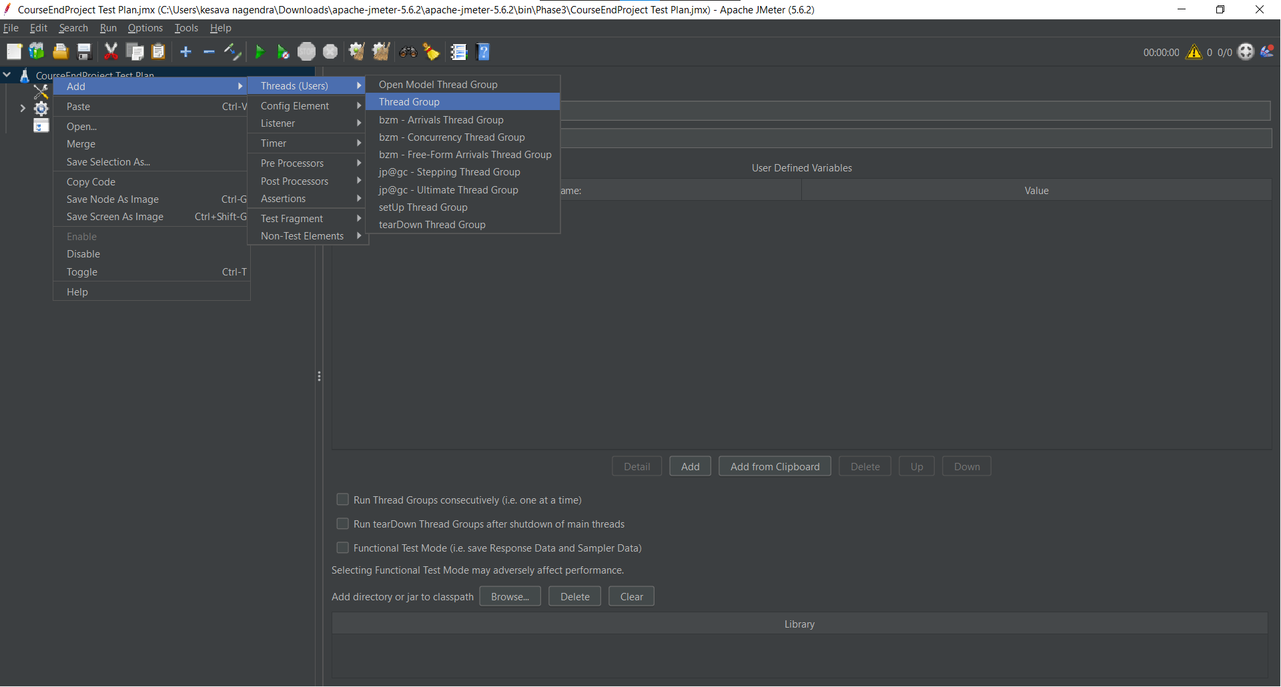

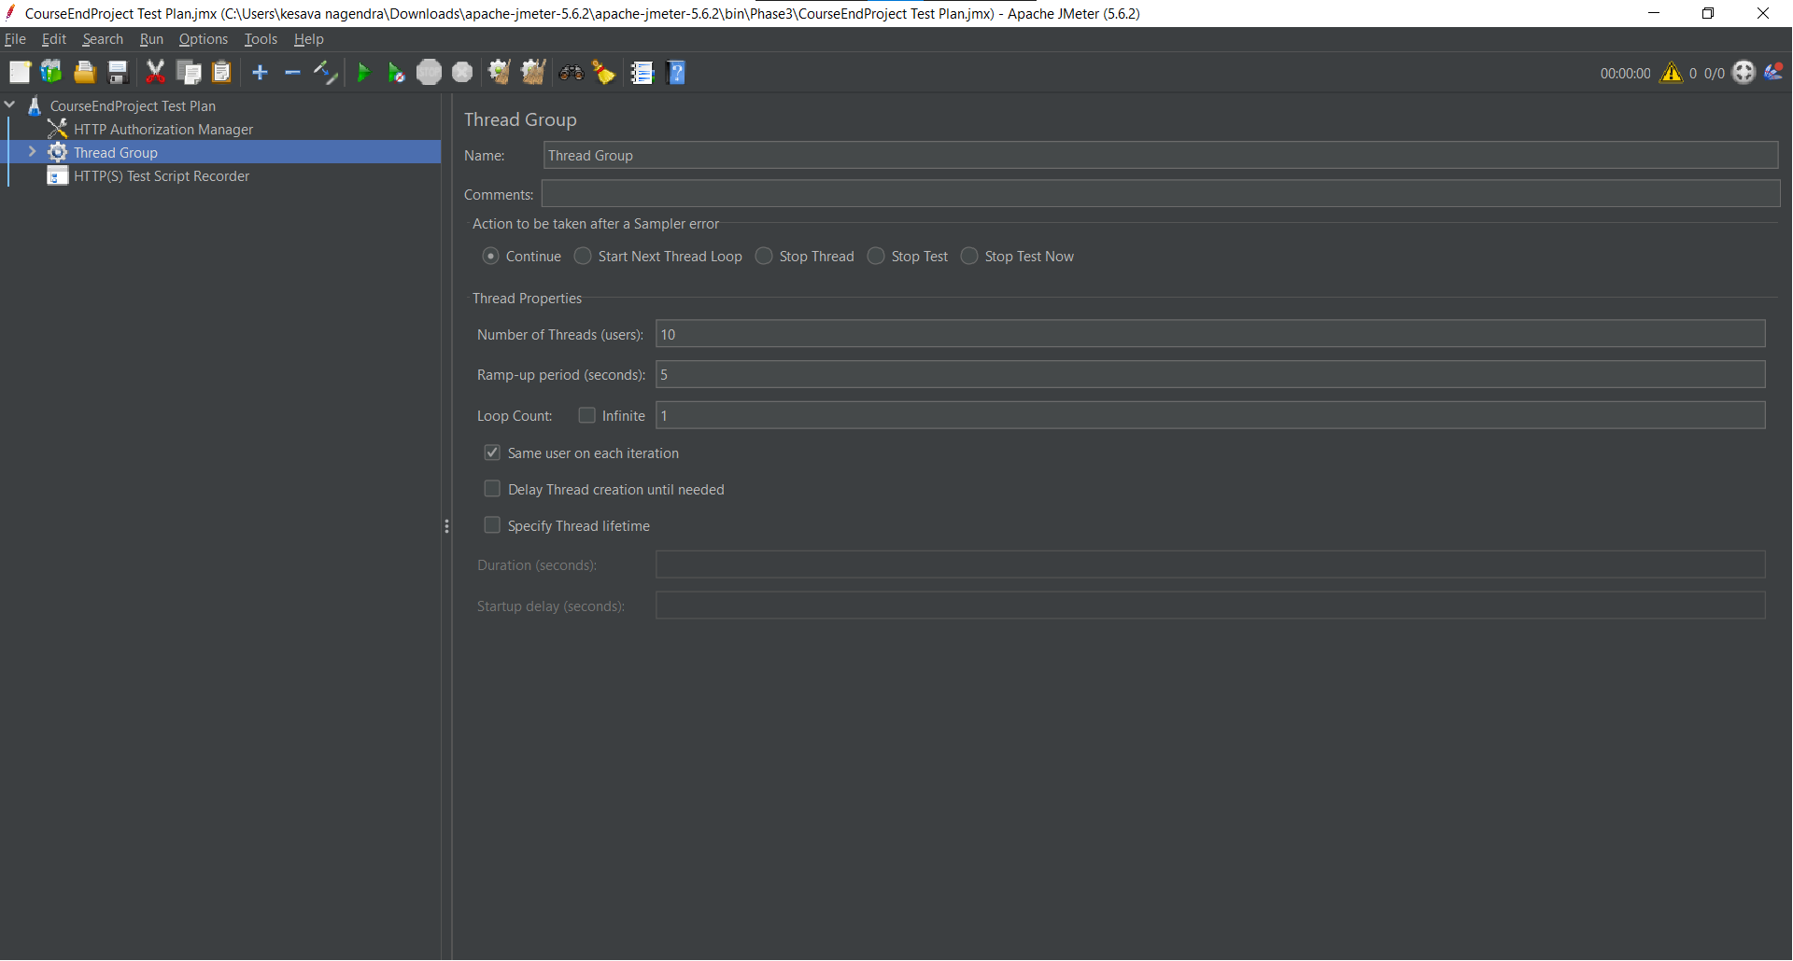

In the Test plan added the HTTP(s) Script Recorder.

Right click on Test plan->Add->NonTest Elements-> HTTP(s) Script Recorder.

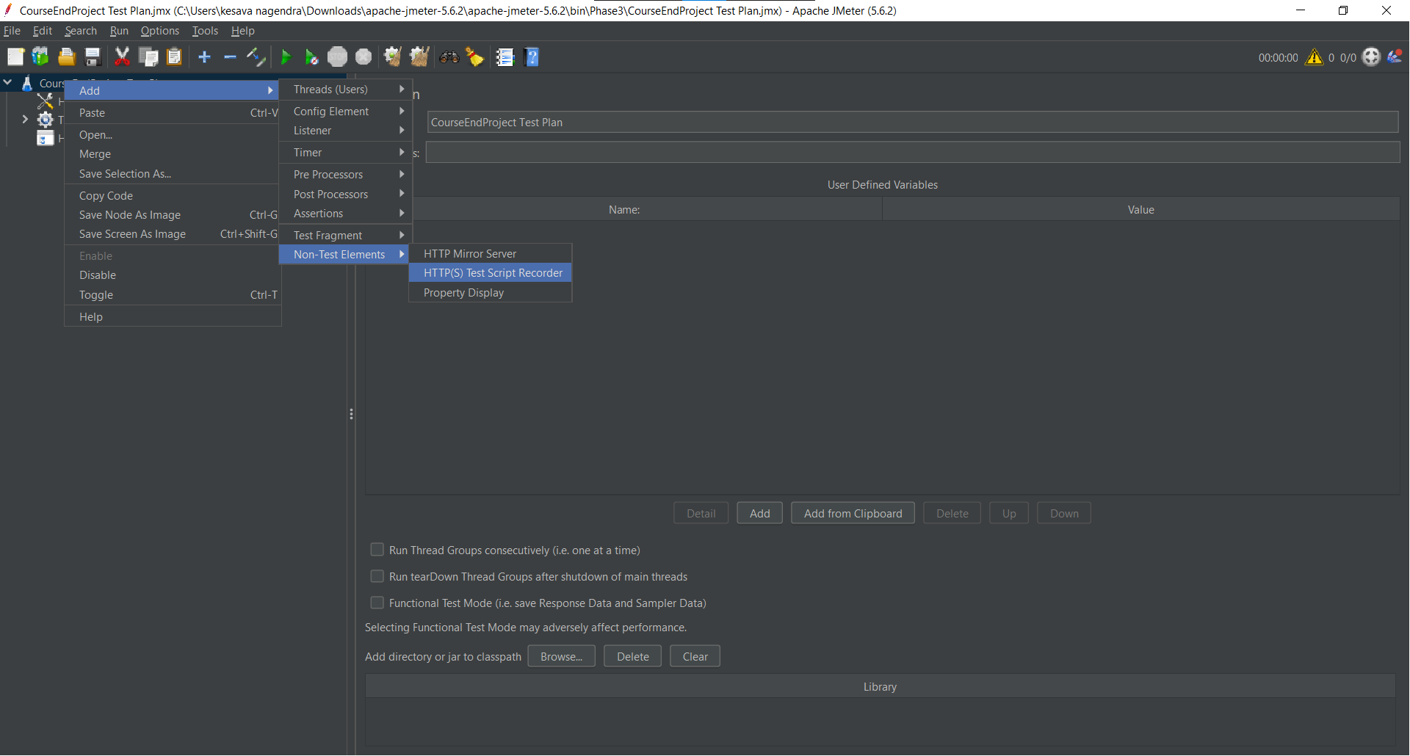

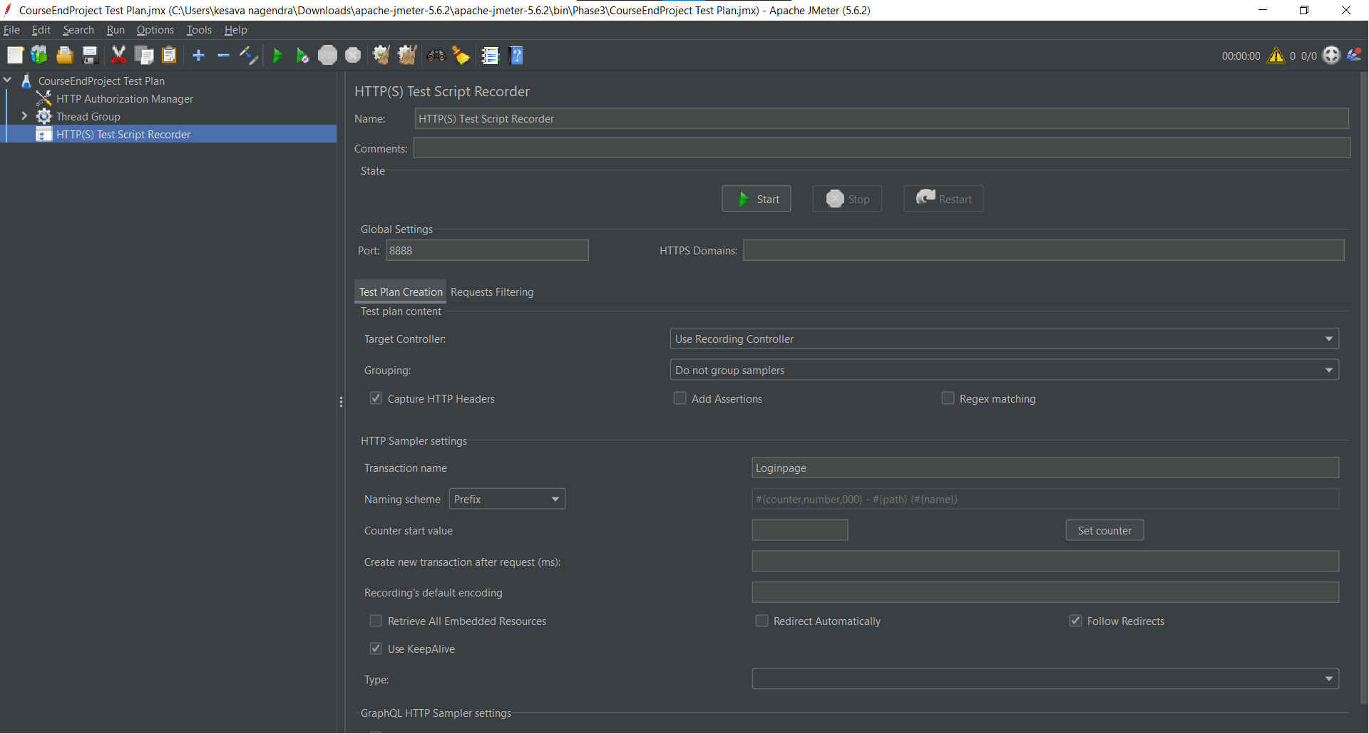

In the Thread Group added the Recording Controller

Right click on Thread Group->Logic Controller->Recording Controller.

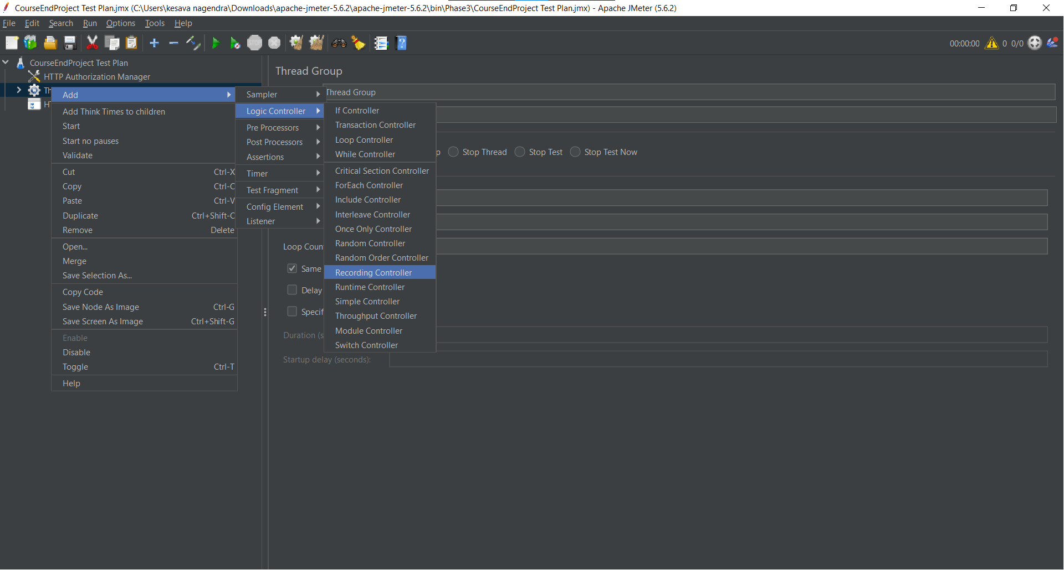

In the HTTP(s) Script Recorder added the target controller to store the requests.

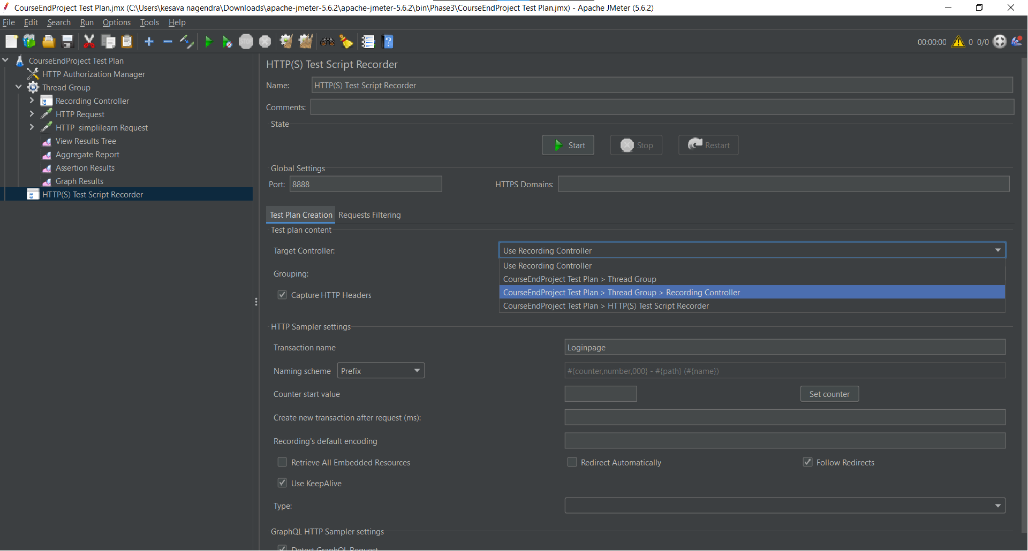

After set the target click on the start button to start the script recording.

Samplers will be stored under the target i.e; Recording Controllers.

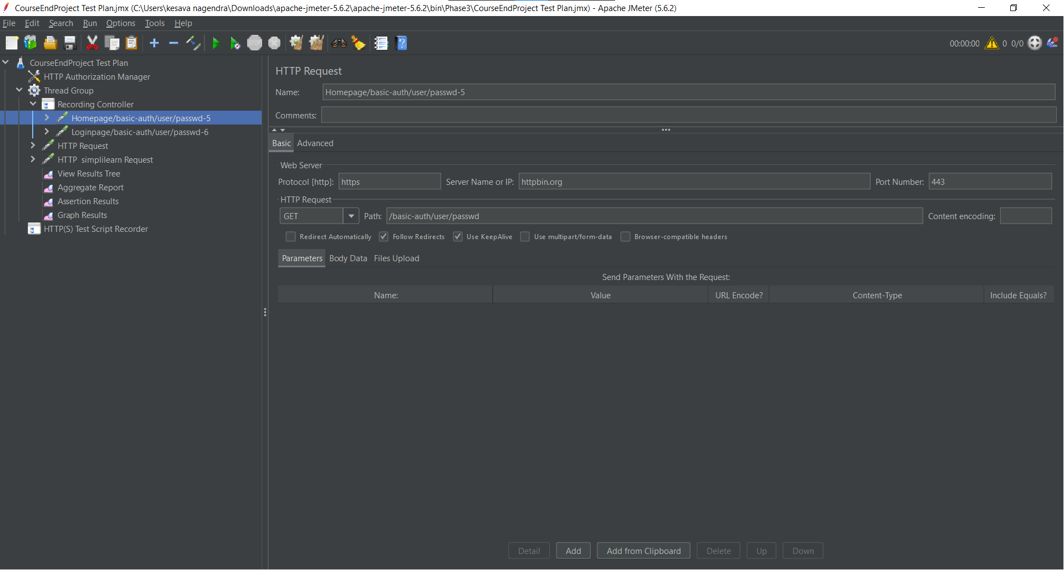

And then Changing the Recording Controller into the simple controller.

Right click on controller->change controller->Logic controller->Simple Controller.

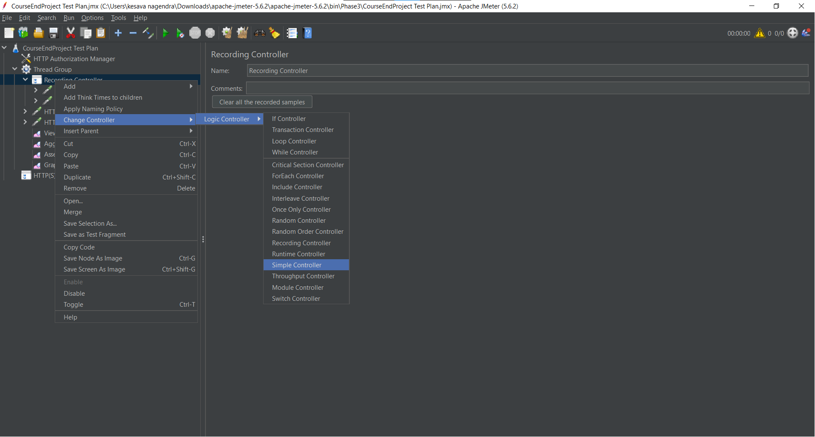

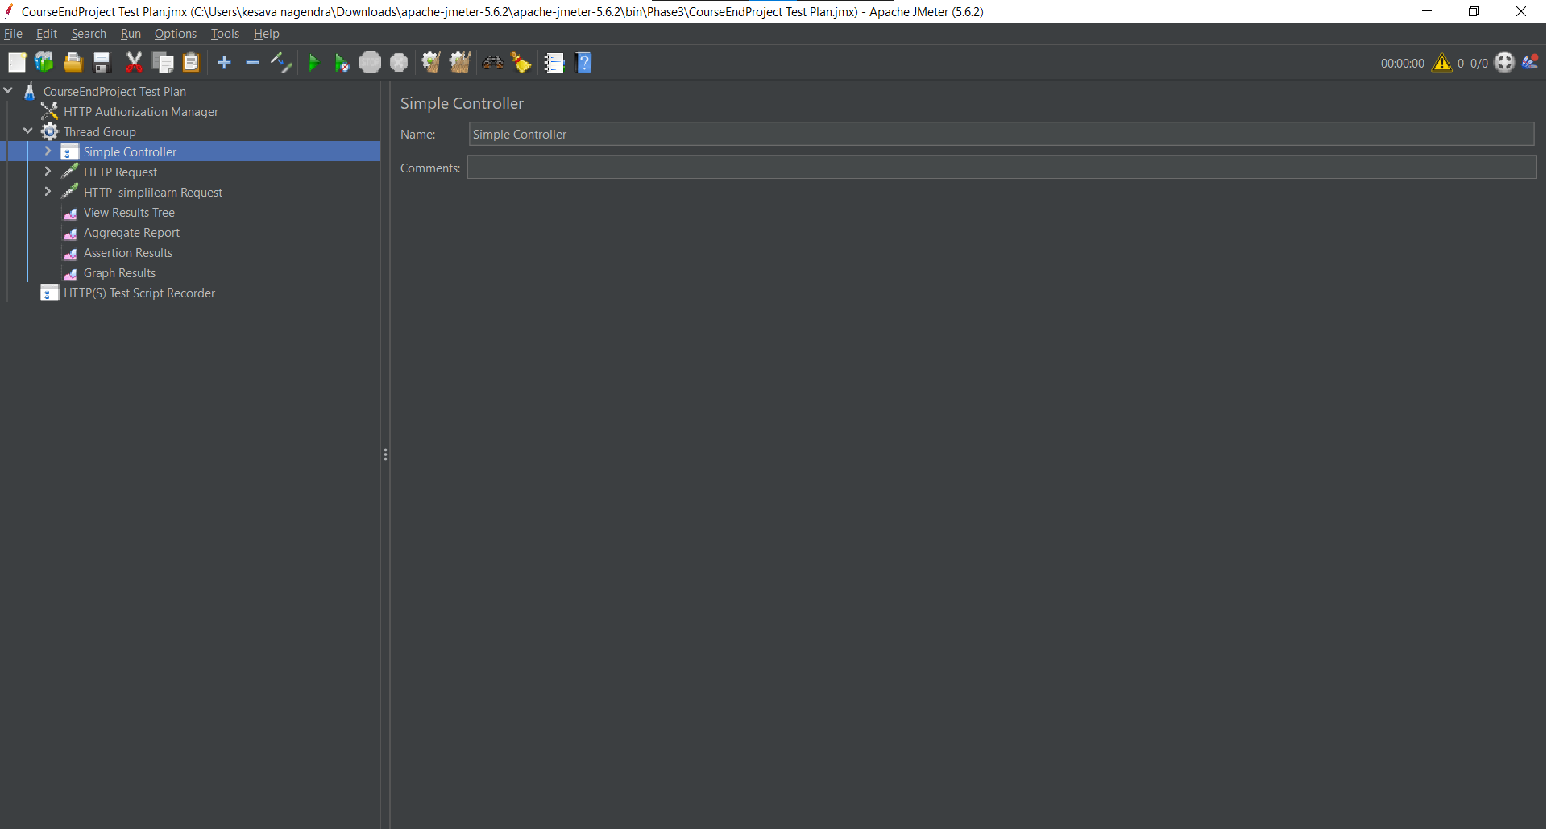

Next, In the Thread Group added the HTTP Request sampler. Added the link “https://httpbin.org /basic-auth/user/passwd”

Right click on Thread Group->Add->sampler->HTTP Request.

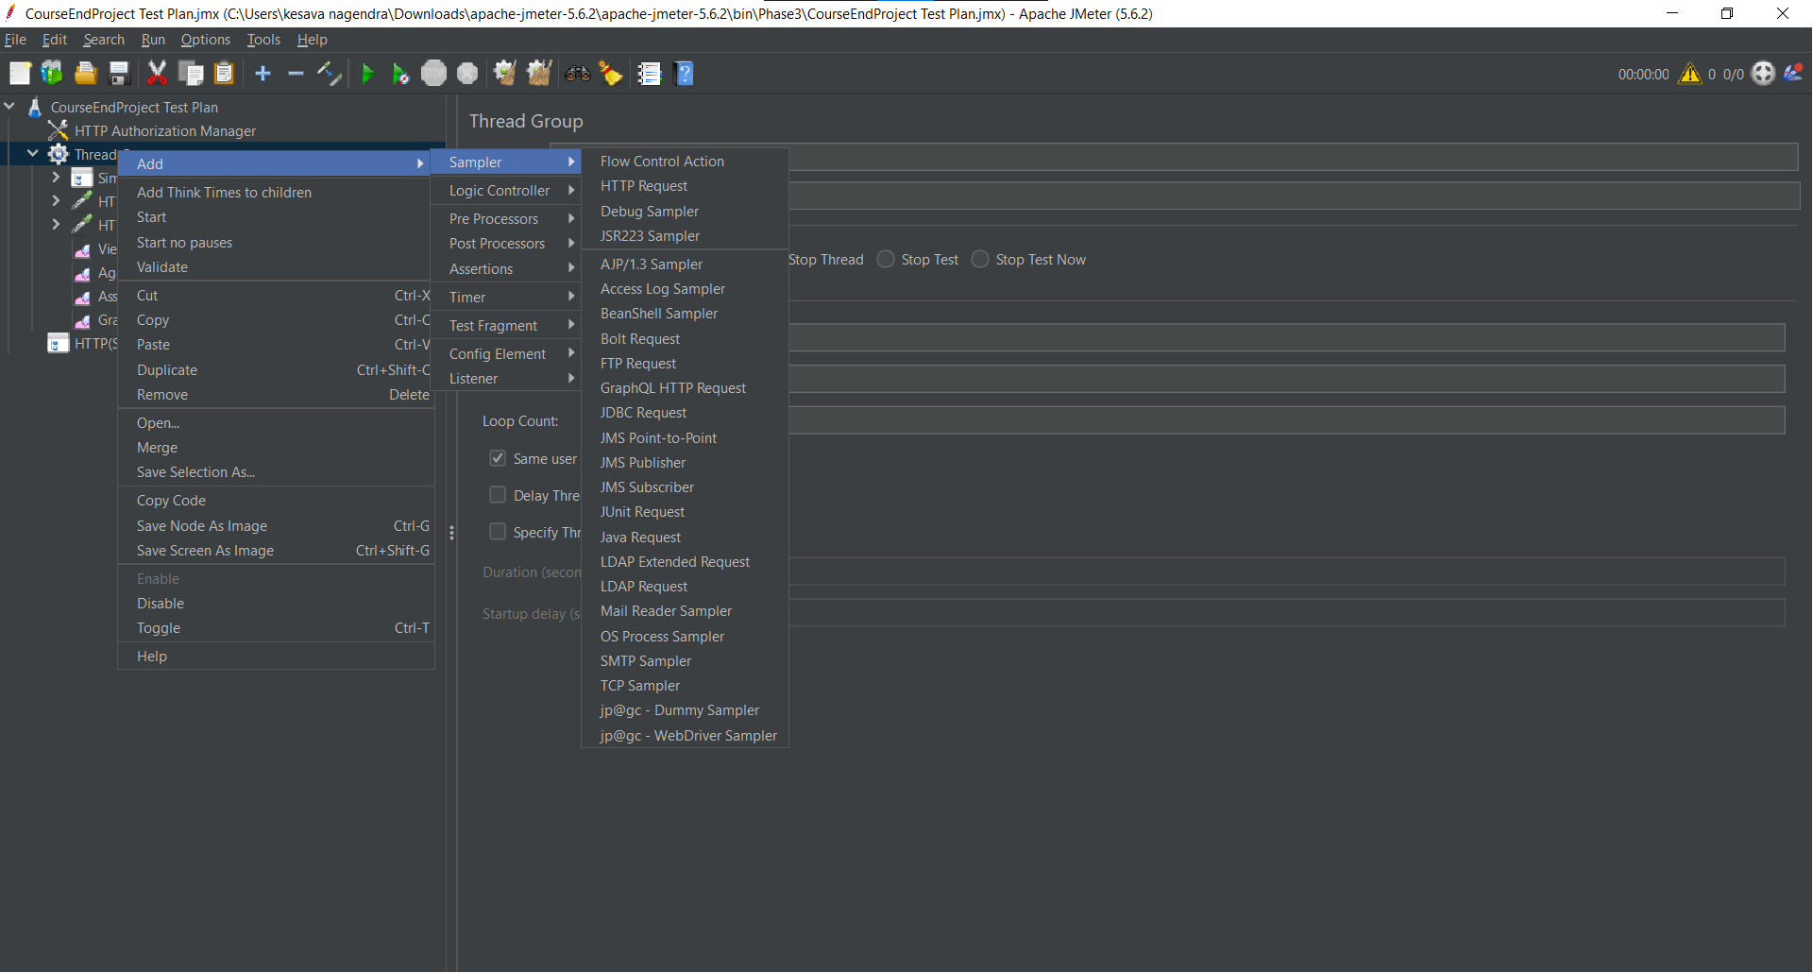

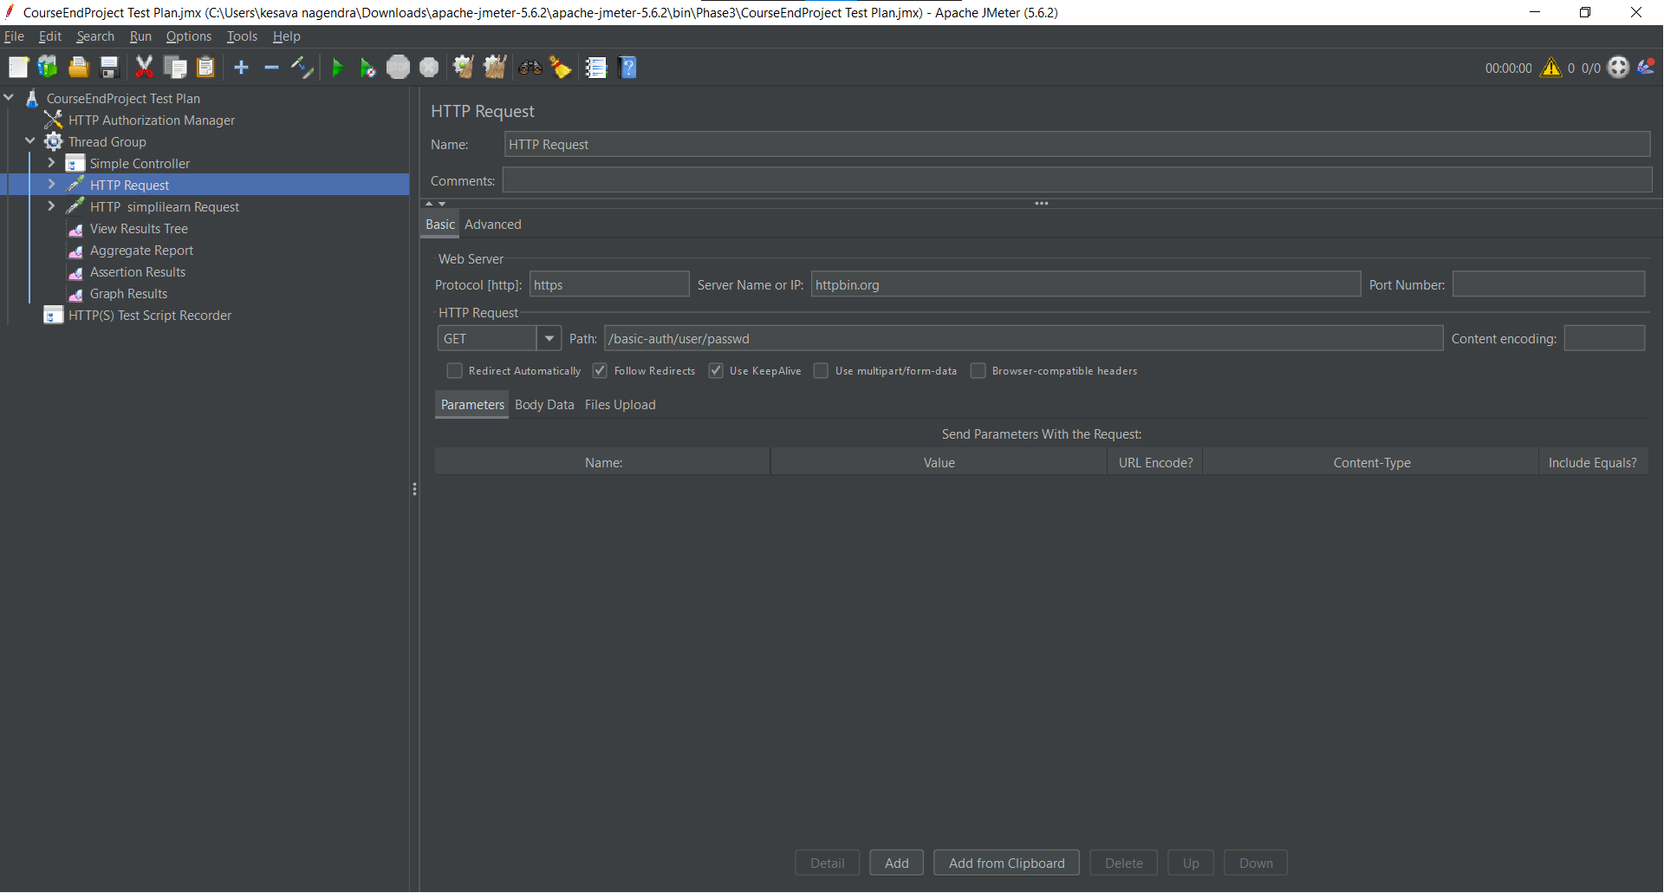

In the HTTP Request added the JSON Assertion.

Right click on HTTP Request->Add->Assertions->JSON Assertion

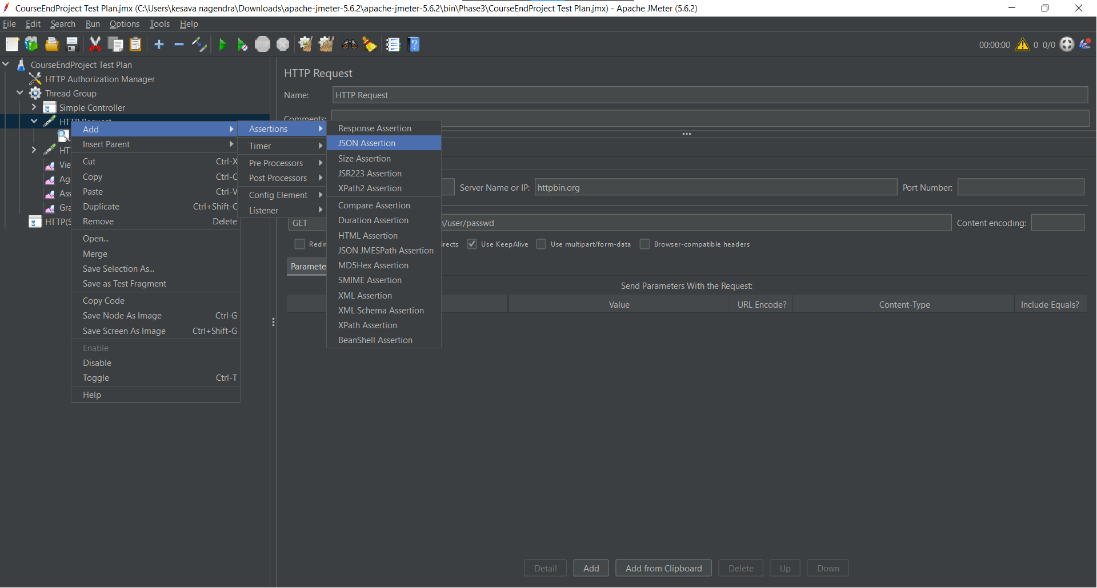

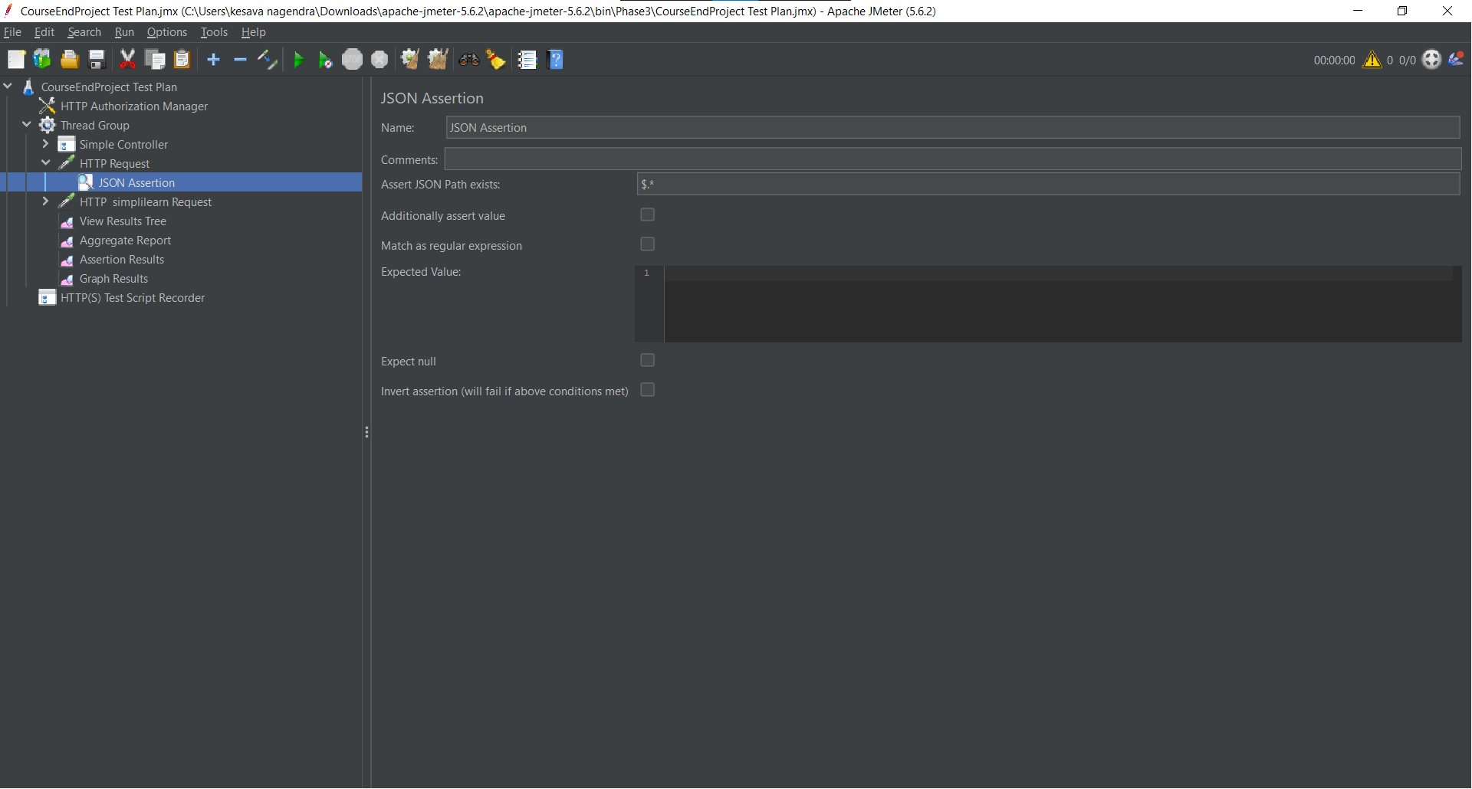

In the Thread Group added the another HTTP Request. Added the link “https:// [www.simplilearn.com/](http://www.simplilearn.com/)”.



In the HTTP Request added the XPath Assertion.

Right click on HTTP Request->Add->Assertion->XPath Assertion.

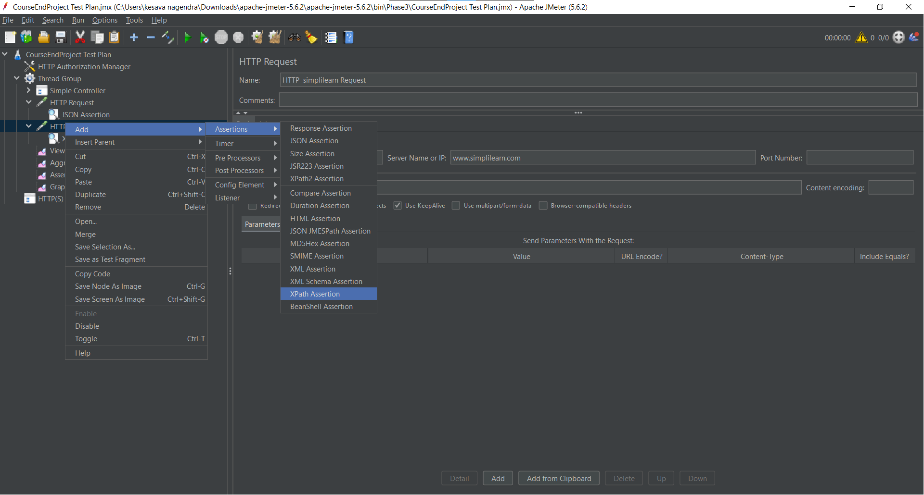

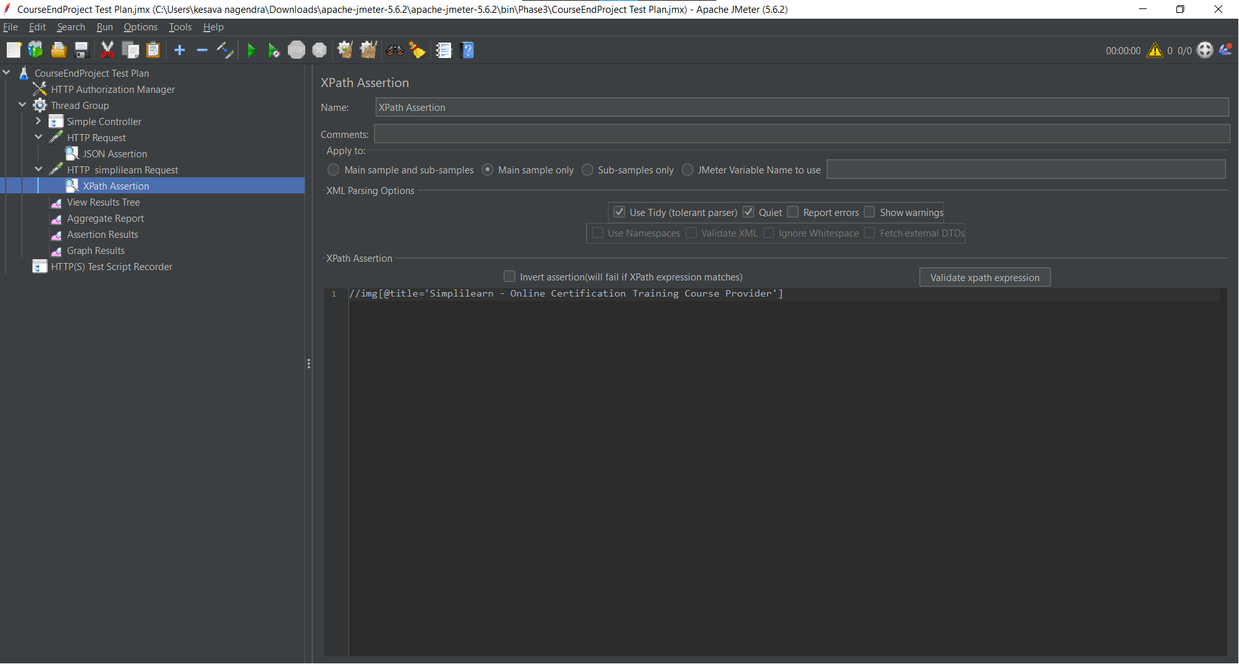

In the Thread Group added the Listeners to view the results.

Here added the View Results Tree , Assertion Results and Aggregate Reports.

Right click on Thread Group->Add->Listener->View Results Tree.

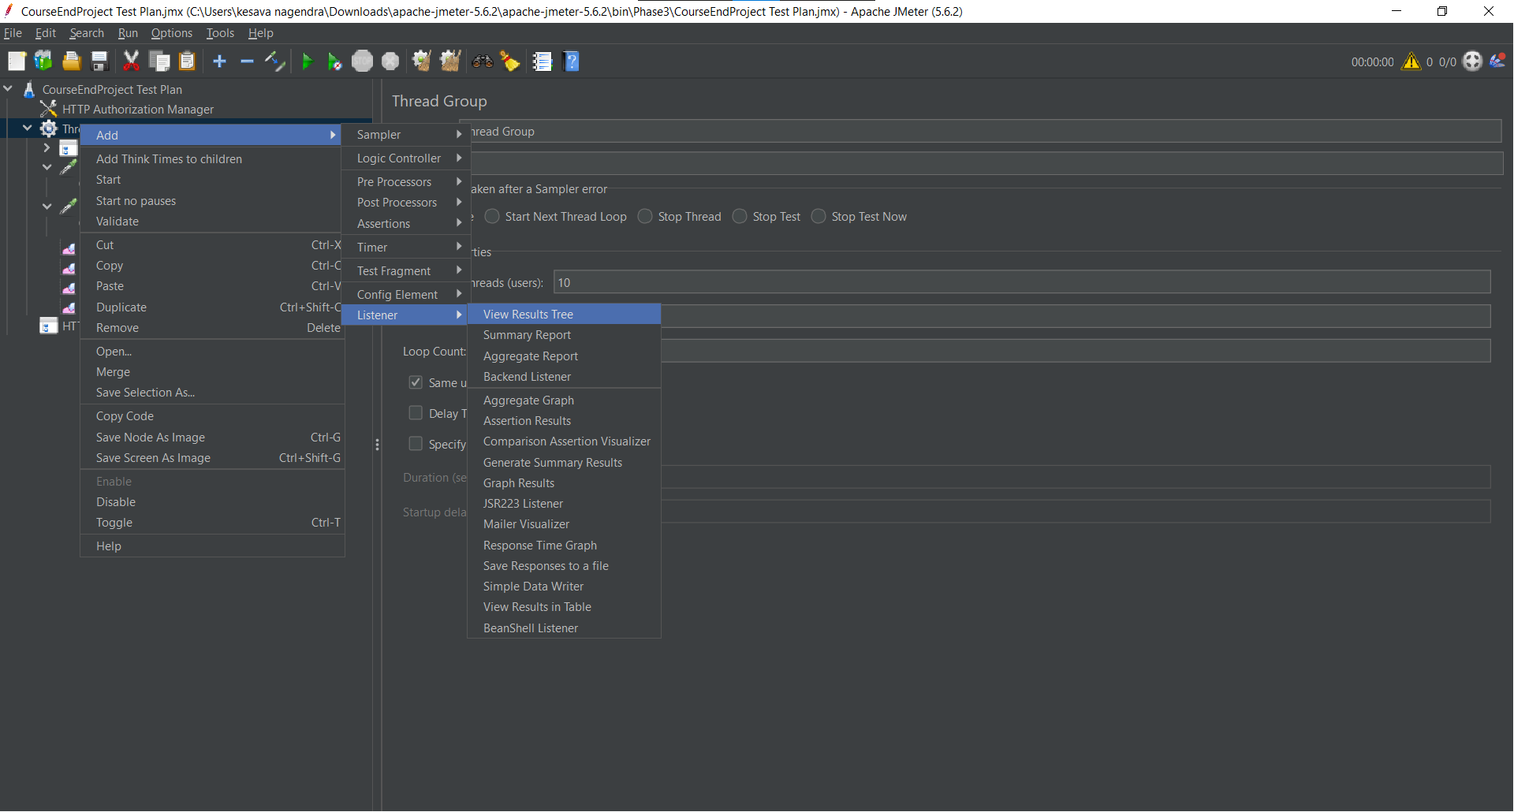

**Outputs:-**

**View Result Tree**

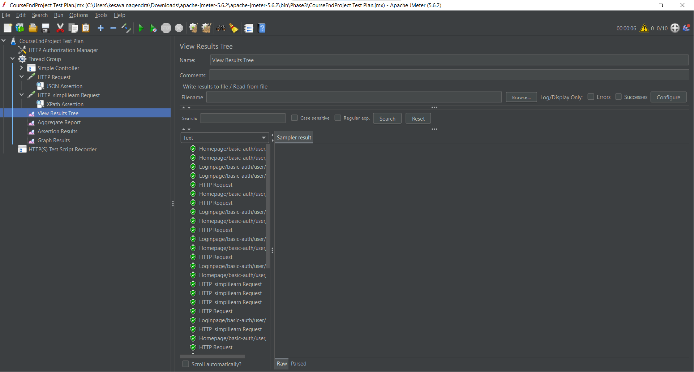

**View of Aggregate Report**

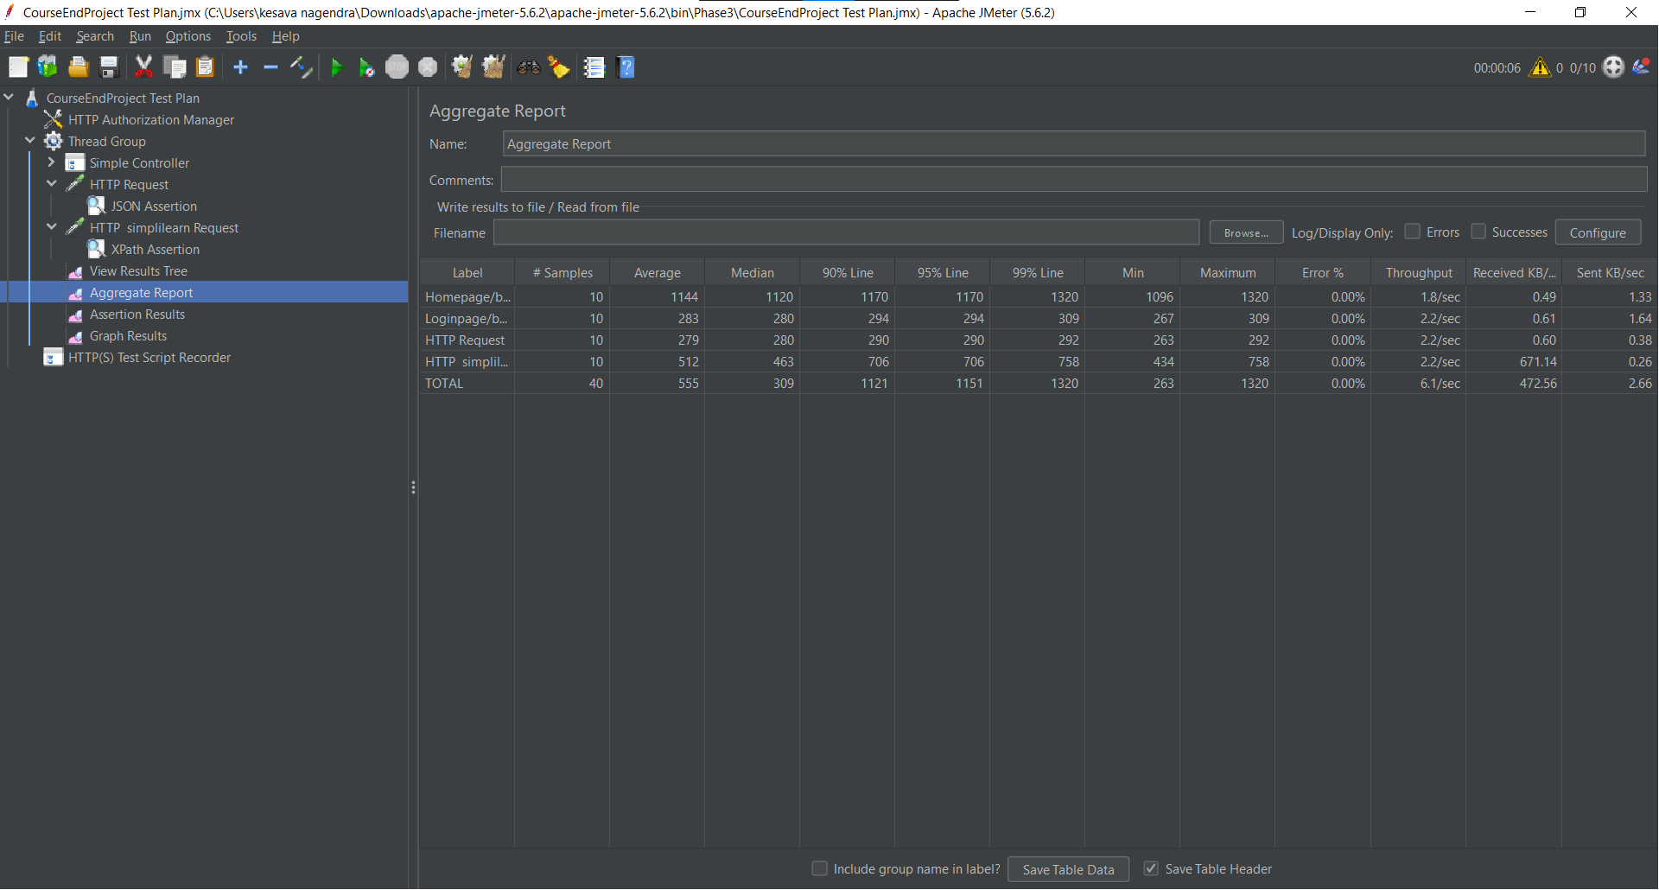

**View of Assertion Results**

